PES UNIVERSITY
Department of Computer Science and Engineering
DBMS Experiential Learning – Level 3 Project
PROJECT REPORT
Corporate Recruitment & Candidate Resume Indexing System
RecruitIQ – MySQL + Qdrant vector database + Next.js
Item | Details
Team | Team 10
Team members | PES2UG24CS535, PES2UG24CS527
Course instructor | Dr. Nagasundari S
Databases | MySQL 8 (relational, source of truth) + Qdrant (vector database)
Application stack | Next.js 14 (App Router + Route Handlers), JWT authentication, role-based access
Academic period | October 2026

Contents
1. Objectives and Functional Requirements
2. ER Diagram and Relational Schema
3. Database Choice and Justification
4. Data Dictionary
5. SQL and Vector Database Implementation
6. Important Queries
7. System Architecture
8. Application Screenshots
9. Testing Results
10. Conclusion

1. Objectives and Functional Requirements

1.1 Problem statement
Companies receive hundreds of applications per opening, and recruiters struggle to find the right candidates in free-text resumes. Candidates, in turn, cannot easily tell which openings suit their skills. This project builds a recruitment platform that manages the full hiring lifecycle and goes beyond CRUD: business rules are enforced inside the database, hiring is transactional, jobs are scored against candidate skills, and resumes and job descriptions are matched by meaning using vector embeddings.

1.2 Objectives
- Model the hiring lifecycle (company, department, job, application, interview, hire) in a normalised MySQL schema with integrity enforced at the database level.
- Demonstrate advanced SQL: views, stored function and procedures, triggers, transactions with row locking, indexes and full-text search.
- Add semantic search with a vector database so that resumes and job descriptions can be matched on meaning rather than keywords.
- Provide a secure, role-based Next.js web application (Admin, Recruiter, Candidate) with no credentials hard-coded in the source.
- Keep the code in Git/GitHub with documented setup and test cases.

1.3 Functional requirements
ID | Requirement | Role
FR1 | Register and log in with hashed passwords; JWT session in an HttpOnly cookie | All
FR2 | Maintain profile and skills; upload multiple resumes | Candidate
FR3 | Search jobs (full-text, location, type, salary) and see skill-match percentage | Candidate
FR4 | Apply to a job (only open jobs, resume mandatory, no duplicate applications) | Candidate
FR5 | Post, close and reopen jobs with required skills | Recruiter
FR6 | Review applications, change status; every change is audit-logged | Recruiter
FR7 | Schedule, complete and cancel interviews | Recruiter
FR8 | Hire a candidate atomically (reject other applicants, close the job) | Recruiter
FR9 | Analytics dashboard: funnel, salary by industry, top skills | Recruiter, Admin
FR10 | Semantic search: recommended jobs for a resume; matching resumes for a job | Candidate, Recruiter
FR11 | Global visibility of all data; job deletion | Admin

1.4 Coverage of the Level 3 requirements
Requirement | Where it is satisfied
SQL + vector database (Option 2) | MySQL 8 for relational data; Qdrant for resume and job embeddings (Sections 3, 5)
ER diagram and relational schema | Section 2 (updated to match the implementation)
DDL: CREATE, ALTER, DROP, keys, constraints, indexes, views | Section 5.1 to 5.3
DML: INSERT, UPDATE, DELETE, SELECT and complex queries | Sections 5.5 and 6
At least four advanced SQL concepts + one vector concept | Transactions, views, function and procedures, triggers, indexing, full-text search; vector similarity search (Section 5.7)
Next.js web interface and API layer | Section 8; 13 route handlers, 8 pages
Credentials not hard-coded | Environment variables in .env (Section 7)
Authentication and at least two roles | bcrypt + JWT; Admin, Recruiter, Candidate (Section 7.3)
Data validation and integrity at database level | NOT NULL, UNIQUE, CHECK, FK, triggers; tested in Section 9
Testing | 23 test cases: constraints, triggers, procedures, security and semantic search (Section 9)

2. ER Diagram and Relational Schema

2.1 Initial design (hand-drawn)
The first design was drawn by hand during the planning phase. It identified the core entities (Company, Department, Job, Candidate, Resume, Skill, Application, Interview) and their relationships.
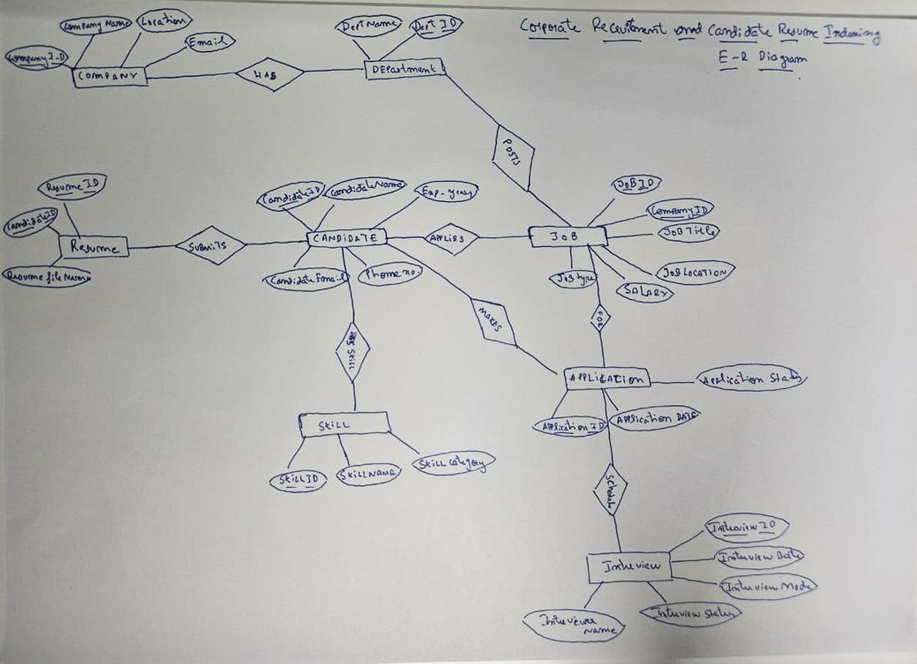
Figure 1: Initial hand-drawn ER diagram (design draft)

2.2 Changes made during implementation
While implementing the database, the design was refined. The table below lists every difference between the initial draft and the final, executed schema; the updated ER diagram in Section 2.3 reflects all of them.
Initial draft | Final implementation | Reason
Recruiter entity | Replaced by the Users entity (Role = Recruiter, linked to Company) | One authentication table serves all roles (RBAC)
Candidate_Phone, Education, Experience entities | Phone, Qualification and Experience_Years as Candidate attributes | Simpler 3NF design; matches the executed DDL
Job_Posting (Dept_ID, Recruiter_ID) | Job with Company_ID, optional Dept_ID, Posted_Date and Status | Open/closed lifecycle; company-level ownership
Skill relates to Candidate only | New Job_Skill (M:N between Job and Skill) | Enables the skill-match function
No authentication entity | New Users entity | Login with hashed passwords and roles
No history of status changes | New Application_Status_Log (filled by trigger) | Audit trail for every application
Interview (as drawn) | Interview with Interviewer_Name, Interview_Date, Mode, Status and Feedback | Matches the drawn ER; adds integrity constraints

2.3 Updated ER diagram
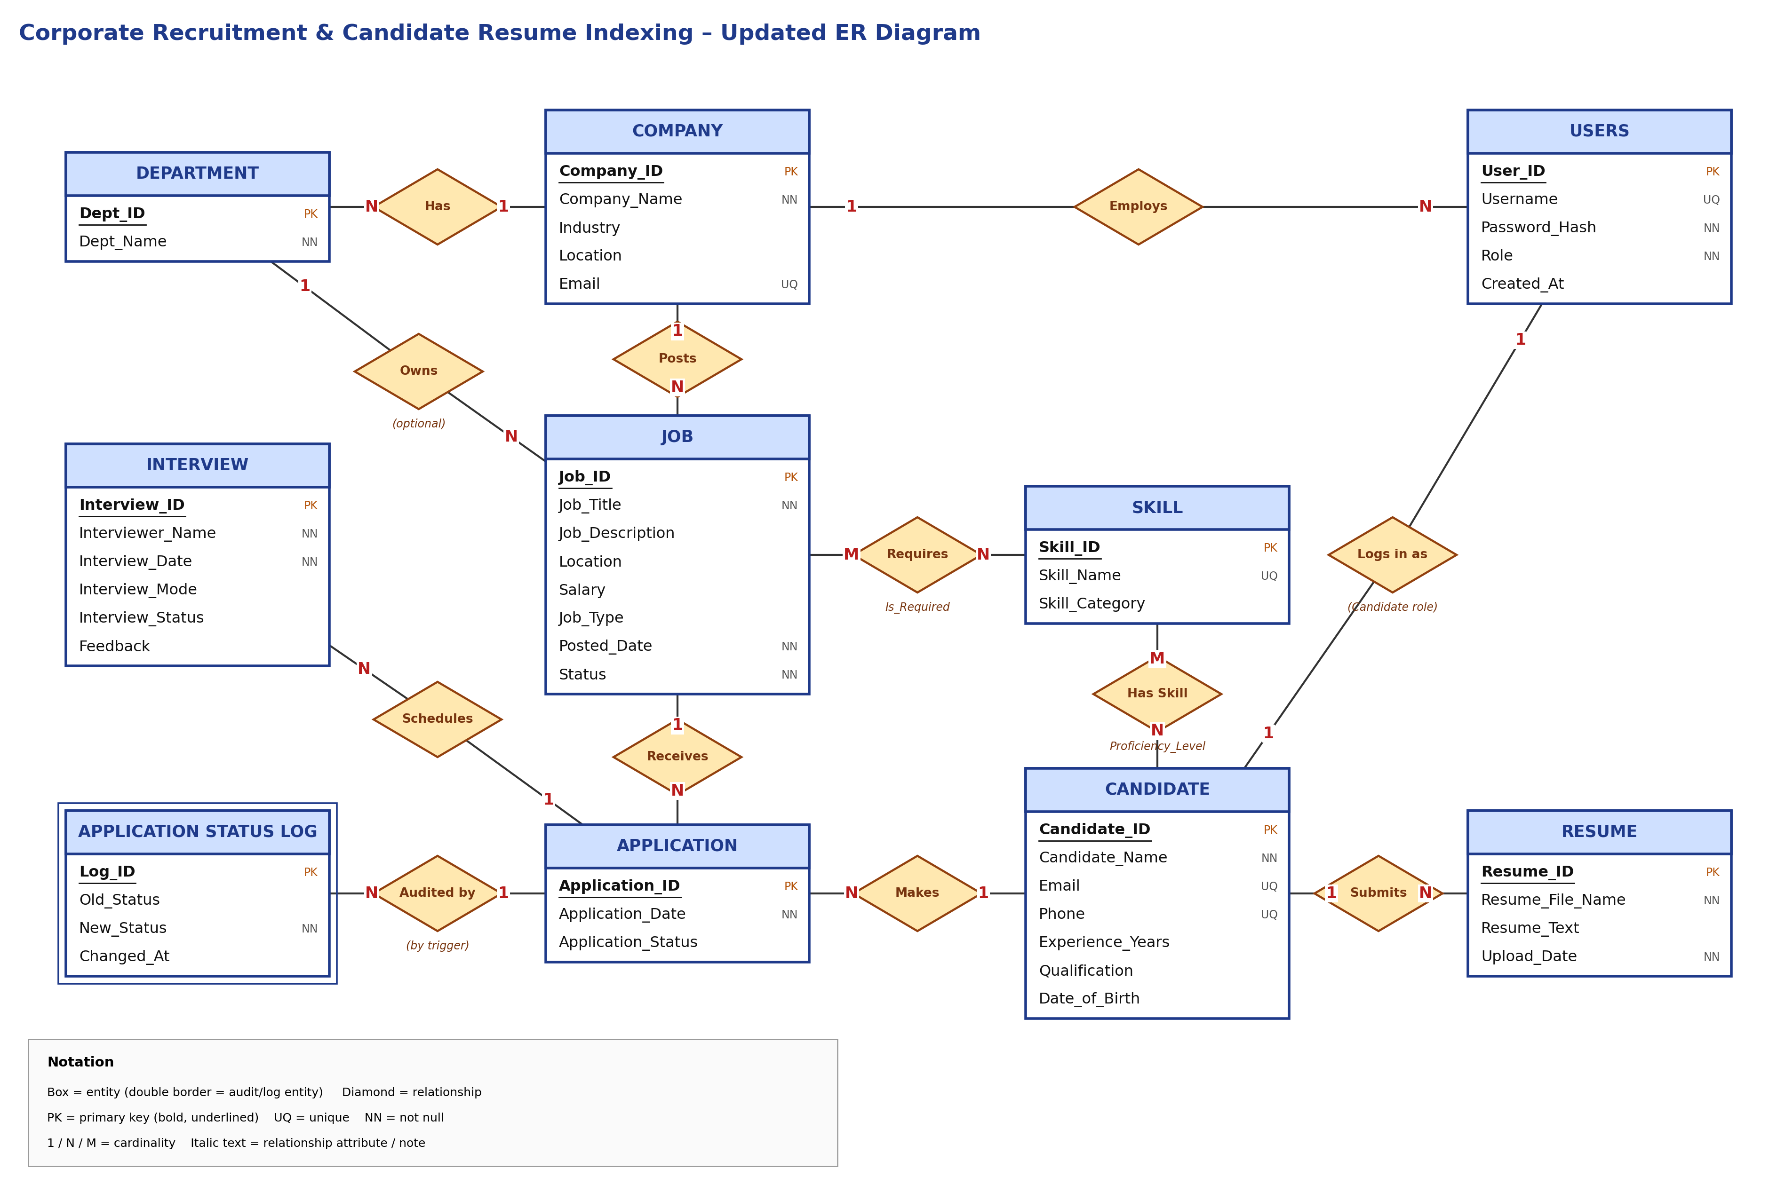
Figure 2: Updated ER diagram of the implemented database (10 entities, 12 relationships)

2.4 Relational schema
The ER diagram was converted to the relational schema below. Many-to-many relationships (Job–Skill, Candidate–Skill) are resolved into junction tables with composite primary keys. Primary keys are bold and underlined, foreign keys are in italics, and arrows point from a foreign key to the table it references.
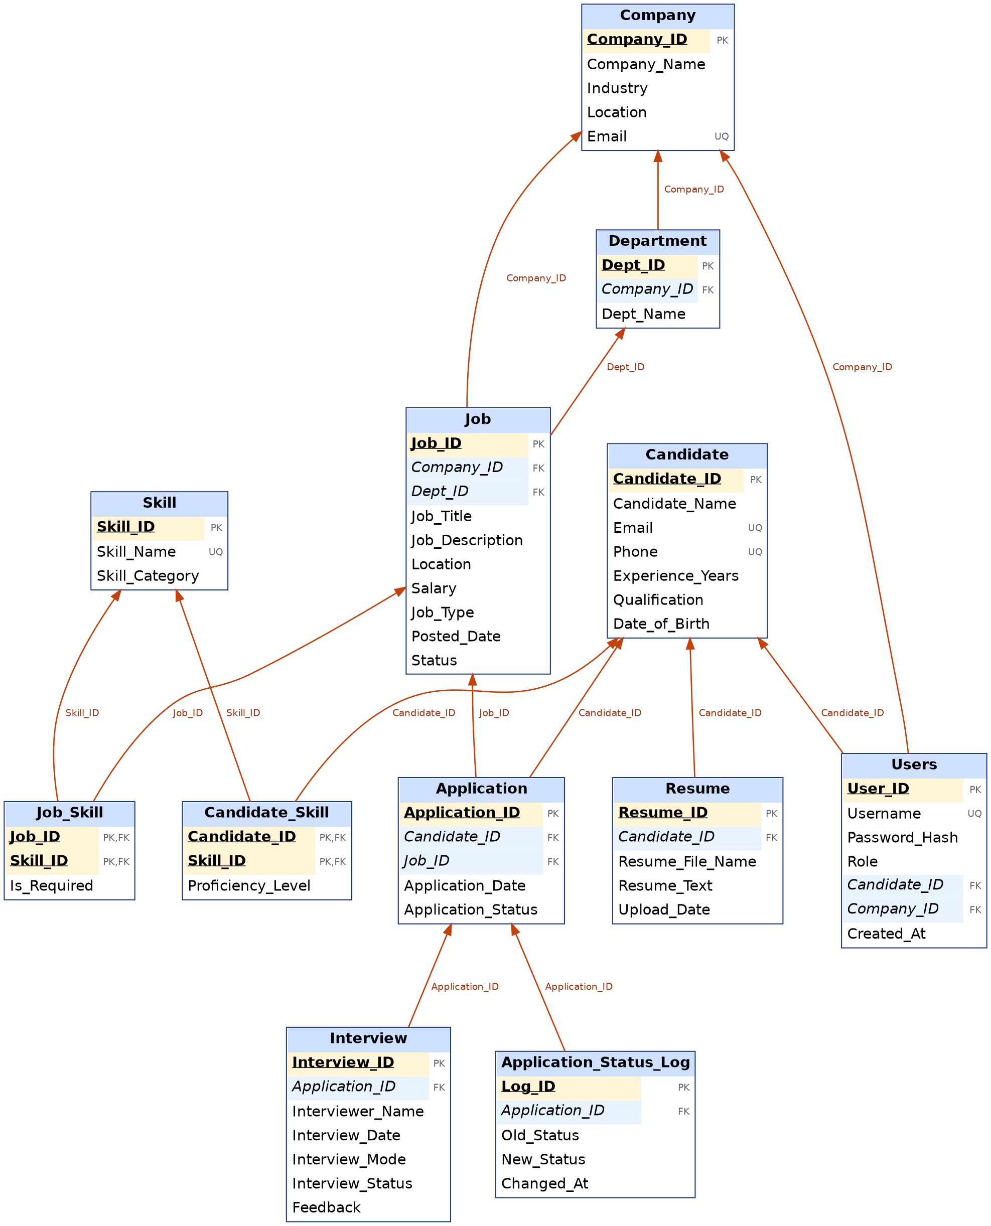
Figure 3: Relational schema with primary keys, foreign keys and references

Schema in relational notation
Company(Company_ID PK, Company_Name, Industry, Location, Email UQ)
Department(Dept_ID PK, Company_ID FK, Dept_Name)
UQ(Company_ID, Dept_Name)
Job(Job_ID PK, Company_ID FK, Dept_ID FK null, Job_Title, Job_Description, Location,
Salary, Job_Type, Posted_Date, Status)
Skill(Skill_ID PK, Skill_Name UQ, Skill_Category)
Job_Skill(Job_ID FK, Skill_ID FK, Is_Required)
PK(Job_ID, Skill_ID)
Candidate(Candidate_ID PK, Candidate_Name, Email UQ, Phone UQ, Experience_Years,
Qualification, Date_of_Birth)
Candidate_Skill(Candidate_ID FK, Skill_ID FK, Proficiency_Level)
PK(Candidate_ID, Skill_ID)
Resume(Resume_ID PK, Candidate_ID FK, Resume_File_Name, Resume_Text, Upload_Date)
Application(Application_ID PK, Candidate_ID FK, Job_ID FK, Application_Date,
Application_Status)
UQ(Candidate_ID, Job_ID)
Interview(Interview_ID PK, Application_ID FK, Interviewer_Name, Interview_Date,
Interview_Mode, Interview_Status, Feedback)
Application_Status_Log(Log_ID PK, Application_ID FK, Old_Status, New_Status,
Changed_At)
Users(User_ID PK, Username UQ, Password_Hash, Role,
Candidate_ID FK null, Company_ID FK null, Created_At)

Referential actions
Foreign key | ON DELETE | Reasoning
Job.Company_ID → Company | RESTRICT | A company with jobs cannot be deleted
Job.Dept_ID → Department | SET NULL | Removing a department keeps its jobs
Department.Company_ID → Company | CASCADE | Departments belong to a company
Resume.Candidate_ID → Candidate | CASCADE | Resumes have no meaning without the candidate
Candidate_Skill → Candidate / Skill | CASCADE | Junction rows removed with either parent
Job_Skill → Job / Skill | CASCADE | Junction rows removed with either parent
Application → Candidate / Job | RESTRICT | Hiring history must never be lost silently
Interview.Application_ID → Application | CASCADE | Interviews belong to an application
Users.Candidate_ID → Candidate | CASCADE | Login removed with the candidate
Users.Company_ID → Company | SET NULL | Recruiter account survives company removal

Normalisation
All tables are in third normal form (and BCNF): every non-key attribute depends on the key, the whole key and nothing but the key. Company data is stored once and referenced from Job; skill names are stored once in Skill and referenced from Candidate_Skill and Job_Skill; multi-valued facts (skills, resumes, interviews) live in their own tables.

3. Database Choice and Justification
The project uses two database paradigms (Option 2: SQL + Vector database). Each type of data is stored where its nature fits best.
Data | Store | Why
Companies, departments, jobs, candidates, applications, interviews, users, skills | MySQL 8 | Strongly structured and highly relational. Needs ACID transactions (hiring), foreign keys, CHECK/UNIQUE constraints, triggers, views and aggregate queries with joins.
Resume text and job descriptions (unstructured, text-heavy) | Qdrant (vector database) | Keyword search cannot match "ML engineer" with "builds recommendation models". Sentence embeddings with cosine similarity retrieve semantically similar resumes and jobs.

Why not a document database such as MongoDB?
The data is relational (a hire touches Application, Job and the audit log atomically) and needs enforced integrity. The only unstructured part needs similarity search rather than flexible documents, which a vector database provides directly.

How the two stores work together
MySQL remains the single source of truth. Qdrant holds a derived index of resume and job vectors, keyed by Resume_ID and Job_ID. A semantic query is answered in two steps: Qdrant returns the nearest IDs, then MySQL filters them (for example only open jobs) and enriches them with names, skills and the skill-match percentage. If the vector index is lost it can be rebuilt from MySQL with one command.

Why Qdrant and a local embedding model
- Qdrant is a purpose-built vector database with HNSW indexing, runs in one Docker container and has a web dashboard.
- The all-MiniLM-L6-v2 model (384 dimensions) runs locally through ONNX, so no API key or network service is required and no resume text leaves the machine.

4. Data Dictionary
Constraint names in brackets are the names used in the DDL and shown in the error messages of Section 9.

Company
Column | Data type | Constraints | Description
Company_ID | INT | PK, AUTO_INCREMENT | Unique company identifier
Company_Name | VARCHAR(100) | NOT NULL | Registered name
Industry | VARCHAR(50) |  | Industry sector
Location | VARCHAR(100) |  | Head-office city
Email | VARCHAR(100) | UNIQUE | HR contact email

Department
Column | Data type | Constraints | Description
Dept_ID | INT | PK, AUTO_INCREMENT | Department identifier
Company_ID | INT | NOT NULL, FK → Company, CASCADE | Owning company
Dept_Name | VARCHAR(80) | NOT NULL, UNIQUE(Company_ID, Dept_Name) | Department name

Job
Column | Data type | Constraints | Description
Job_ID | INT | PK, AUTO_INCREMENT | Job identifier
Company_ID | INT | NOT NULL, FK → Company | Hiring company
Dept_ID | INT | FK → Department, SET NULL | Optional department
Job_Title | VARCHAR(100) | NOT NULL | Title of the opening
Job_Description | TEXT | FULLTEXT (ft_job) | Duties; embedded into Qdrant
Location | VARCHAR(100) | Index idx_job_status_location | Work location
Salary | DECIMAL(10,2) | CHECK ≥ 0 (CHK_Salary) | Annual salary
Job_Type | VARCHAR(30) | CHECK IN Full-time, Part-time, Contract, Internship (CHK_Job_Type) | Employment type
Posted_Date | DATE | NOT NULL, DEFAULT CURRENT_DATE | Posting date
Status | VARCHAR(10) | NOT NULL, DEFAULT Open, CHECK IN Open, Closed (CHK_Job_Status) | Opening lifecycle state

Skill and Job_Skill
Column | Data type | Constraints | Description
Skill.Skill_ID | INT | PK, AUTO_INCREMENT | Skill identifier
Skill.Skill_Name | VARCHAR(50) | NOT NULL, UNIQUE | Skill name, stored once
Skill.Skill_Category | VARCHAR(50) |  | Programming, Database, AI, …
Job_Skill.Job_ID | INT | PK, FK → Job, CASCADE | Job requiring the skill
Job_Skill.Skill_ID | INT | PK, FK → Skill, CASCADE | Required skill
Job_Skill.Is_Required | BOOLEAN | NOT NULL, DEFAULT TRUE | Mandatory or preferred

Candidate
Column | Data type | Constraints | Description
Candidate_ID | INT | PK, AUTO_INCREMENT | Candidate identifier
Candidate_Name | VARCHAR(100) | NOT NULL | Full name
Email | VARCHAR(100) | NOT NULL, UNIQUE | Contact email
Phone | VARCHAR(15) | UNIQUE, CHECK length ≥ 10 (CHK_Phone) | Contact number
Experience_Years | DECIMAL(4,1) | DEFAULT 0, CHECK ≥ 0 (CHK_Experience) | Total experience
Qualification | VARCHAR(100) |  | Highest qualification
Date_of_Birth | DATE | Added with ALTER TABLE | Date of birth

Resume and Candidate_Skill
Column | Data type | Constraints | Description
Resume.Resume_ID | INT | PK, AUTO_INCREMENT | Resume identifier
Resume.Candidate_ID | INT | NOT NULL, FK → Candidate, CASCADE | Owner
Resume.Resume_File_Name | VARCHAR(150) | NOT NULL | Uploaded file name
Resume.Resume_Text | TEXT | FULLTEXT (ft_resume) | Extracted text; embedded into Qdrant
Resume.Upload_Date | DATE | NOT NULL | Upload date
Candidate_Skill.Candidate_ID | INT | PK, FK → Candidate, CASCADE | Candidate
Candidate_Skill.Skill_ID | INT | PK, FK → Skill, CASCADE | Skill known
Candidate_Skill.Proficiency_Level | VARCHAR(30) | CHECK IN Beginner, Intermediate, Advanced, Expert | Skill level

Application
Column | Data type | Constraints | Description
Application_ID | INT | PK, AUTO_INCREMENT | Application identifier
Candidate_ID | INT | NOT NULL, FK → Candidate | Applicant
Job_ID | INT | NOT NULL, FK → Job, UNIQUE(Candidate_ID, Job_ID) | Applied job; one application per job
Application_Date | DATE | NOT NULL | Date applied
Application_Status | VARCHAR(30) | DEFAULT Applied, CHECK IN Applied, Shortlisted, Interview Scheduled, Rejected, Hired (CHK_App_Status) | Pipeline state

Interview
Column | Data type | Constraints | Description
Interview_ID | INT | PK, AUTO_INCREMENT | Interview identifier
Application_ID | INT | NOT NULL, FK → Application, CASCADE | Related application
Interviewer_Name | VARCHAR(100) | NOT NULL | Panel member
Interview_Date | DATETIME | NOT NULL, index idx_interview_date | Scheduled time
Interview_Mode | VARCHAR(10) | CHECK IN Online, Onsite, Phone | Mode
Interview_Status | VARCHAR(10) | CHECK IN Scheduled, Completed, Cancelled | State
Feedback | TEXT |  | Feedback after the interview

Users and Application_Status_Log
Column | Data type | Constraints | Description
Users.User_ID | INT | PK, AUTO_INCREMENT | Account identifier
Users.Username | VARCHAR(50) | NOT NULL, UNIQUE | Login name
Users.Password_Hash | VARCHAR(100) | NOT NULL | bcrypt hash, never plain text
Users.Role | VARCHAR(15) | CHECK IN Admin, Recruiter, Candidate | Access role
Users.Candidate_ID | INT | FK → Candidate, UNIQUE, CASCADE | Set for the Candidate role
Users.Company_ID | INT | FK → Company, SET NULL | Set for the Recruiter role
Log.Log_ID | INT | PK, AUTO_INCREMENT | Log entry
Log.Application_ID | INT | NOT NULL, FK → Application, CASCADE | Audited application
Log.Old_Status / New_Status | VARCHAR(30) | New_Status NOT NULL | Status before and after (written by trigger)
Log.Changed_At | TIMESTAMP | DEFAULT CURRENT_TIMESTAMP | When the change happened

5. SQL and Vector Database Implementation
The database was built in stages using MySQL Workbench. Each script was executed against the CorporateRecruitmentDB database and the output captured below.
Script | Purpose | Demonstrates
01 | Base DDL: 7 tables, ALTER and DROP demonstrations | CREATE, ALTER, DROP, PK/FK, constraints
02 | Schema extensions and indexes | ALTER, new tables, CHECK constraints, indexes, FULLTEXT
03 | Views | Views over joins and aggregates
04 | Function, procedures, triggers | Functions, stored procedures, transactions, triggers
05 | Seed data | INSERT, UPDATE
06 | Important queries | SELECT, JOIN, GROUP BY, HAVING, subqueries, DML
07 | Test cases | Constraint and trigger validation

5.1 Base DDL (script 01)
The seven base tables (Company, Candidate, Job, Resume, Skill, Candidate_Skill, Application) were created first, with primary keys, foreign keys, UNIQUE, NOT NULL, DEFAULT and CHECK constraints (screenshots are part of the separate DDL submission). The ALTER and DROP statements of this script:
ALTER TABLE Candidate ADD Date_of_Birth DATE;

ALTER TABLE Candidate
ADD CONSTRAINT CHK_Phone CHECK (Phone IS NULL OR CHAR_LENGTH(Phone) >= 10);

CREATE TABLE Temporary_Data (Temp_ID INT, Temp_Name VARCHAR(50));
DROP TABLE Temporary_Data;

5.2 Schema extensions and indexes (script 02)
The schema was extended with ALTER TABLE and CREATE TABLE statements so that it matches the final design: Department, Job_Skill, Interview, Users and Application_Status_Log were created; Job received Dept_ID, Posted_Date and Status; CHECK constraints were added to Job, Application and Candidate_Skill.
ALTER TABLE Job
ADD COLUMN Dept_ID INT NULL,
ADD COLUMN Posted_Date DATE NOT NULL DEFAULT (CURRENT_DATE),
ADD COLUMN Status VARCHAR(10) NOT NULL DEFAULT 'Open',
ADD CONSTRAINT FK_Job_Dept FOREIGN KEY (Dept_ID)
REFERENCES Department(Dept_ID) ON DELETE SET NULL,
ADD CONSTRAINT CHK_Job_Status CHECK (Status IN ('Open','Closed')),
ADD CONSTRAINT CHK_Job_Type CHECK (Job_Type IS NULL OR
Job_Type IN ('Full-time','Part-time','Contract','Internship'));

CREATE INDEX idx_job_status_location ON Job(Status, Location);
CREATE INDEX idx_app_job_status ON Application(Job_ID, Application_Status);
CREATE INDEX idx_candidate_exp ON Candidate(Experience_Years);
CREATE INDEX idx_resume_cand_date ON Resume(Candidate_ID, Upload_Date);
CREATE INDEX idx_interview_date ON Interview(Interview_Date);
CREATE FULLTEXT INDEX ft_job ON Job(Job_Title, Job_Description);
CREATE FULLTEXT INDEX ft_resume ON Resume(Resume_Text);
CREATE INDEX idx_tmp ON Company(Industry); DROP INDEX idx_tmp ON Company;

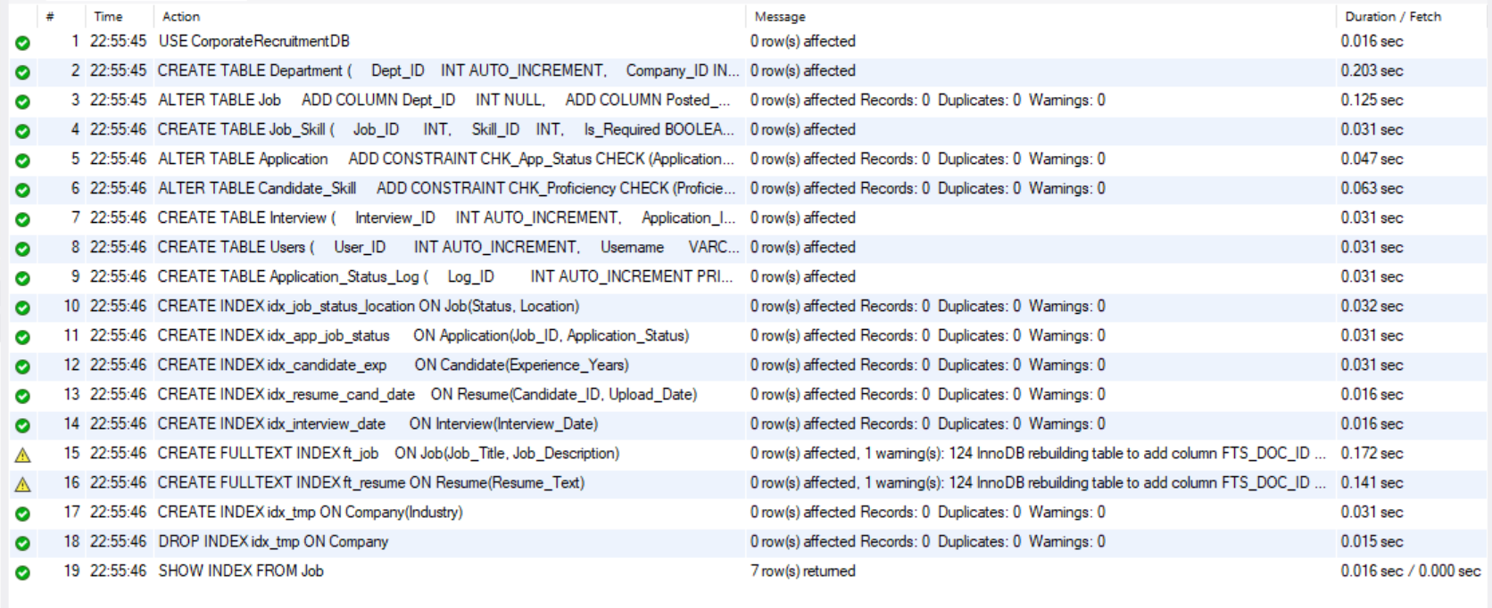
Figure 4: Action output of script 02: all 19 statements executed (the two warnings are InnoDB adding the hidden FTS_DOC_ID column for the first FULLTEXT index)
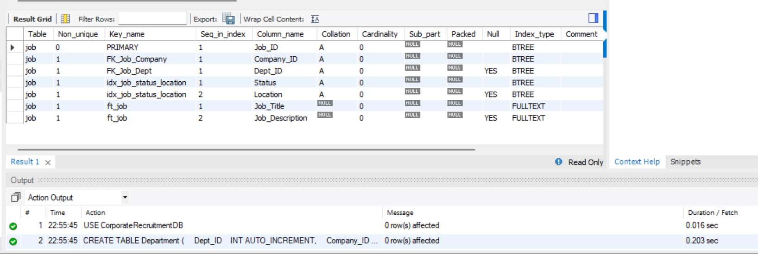
Figure 5: SHOW INDEX FROM Job: primary key, foreign keys, composite index and FULLTEXT index ft_job
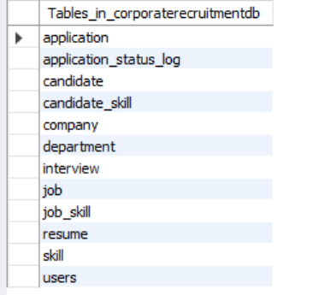
Figure 6: SHOW TABLES: the 12 tables of the final schema

5.3 Views (script 03)
Three views encapsulate frequently used joins and aggregates. They are used directly by the application (dashboard, candidate search and interview schedule).
View | Content
vw_job_summary | Job with company, department, number of applications and number of hires (JOIN, LEFT JOIN, GROUP BY, COUNT, SUM)
vw_candidate_profile | Candidate with all skills concatenated using GROUP_CONCAT and the number of applications (correlated subquery)
vw_interview_schedule | Interview joined with application, candidate, job and company

CREATE OR REPLACE VIEW vw_job_summary AS
SELECT j.Job_ID, j.Job_Title, c.Company_ID, c.Company_Name, d.Dept_Name,
j.Location, j.Salary, j.Status,
COUNT(a.Application_ID) AS Total_Applications,
COALESCE(SUM(a.Application_Status='Hired'),0) AS Hired_Count
FROM Job j
JOIN Company c ON c.Company_ID = j.Company_ID
LEFT JOIN Department d ON d.Dept_ID = j.Dept_ID
LEFT JOIN Application a ON a.Job_ID = j.Job_ID
GROUP BY j.Job_ID, j.Job_Title, c.Company_ID, c.Company_Name, d.Dept_Name,
j.Location, j.Salary, j.Status;

Figure 7: Views created successfully
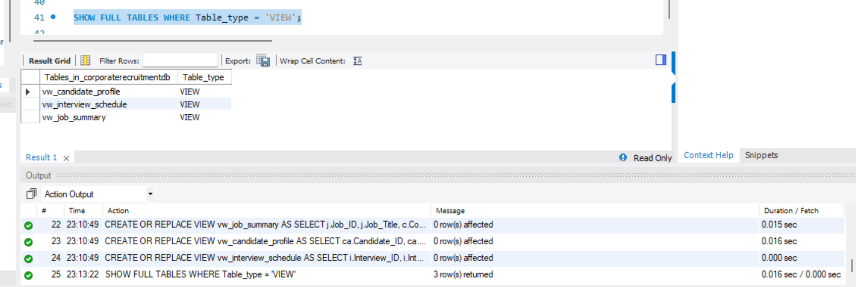
Figure 8: SHOW FULL TABLES WHERE Table_type = VIEW: the three views

5.4 Function, stored procedures and triggers (script 04)
Object | Purpose
fn_match_percentage(candidate, job) | Returns the percentage of a job’s required skills that the candidate has
sp_apply_for_job(candidate, job) | Inserts an application inside a transaction; rolls back on any error
sp_hire_candidate(application) | Locks the row (FOR UPDATE), marks it Hired, rejects all other open applicants and closes the job as one atomic transaction
trg_app_before_insert | Blocks applications to closed jobs and applications without a resume
trg_app_before_update | Makes “Hired” a final state
trg_app_after_insert / after_update | Writes every status change to Application_Status_Log (audit trail)
trg_interview_before_insert | Rejects an interview dated before the application date
trg_interview_after_insert | Moves the application to “Interview Scheduled” automatically

The hiring procedure shows how a transaction keeps data consistent. If any statement fails, the EXIT HANDLER rolls back everything, so a job can never be closed without a hired candidate or vice versa.
CREATE PROCEDURE sp_hire_candidate(IN p_app INT)
BEGIN
DECLARE v_job INT DEFAULT NULL; DECLARE v_status VARCHAR(30);
DECLARE EXIT HANDLER FOR SQLEXCEPTION BEGIN ROLLBACK; RESIGNAL; END;
START TRANSACTION;
SELECT Job_ID, Application_Status INTO v_job, v_status
FROM Application WHERE Application_ID = p_app FOR UPDATE;
IF v_job IS NULL THEN SIGNAL SQLSTATE '45000' SET MESSAGE_TEXT='Application not
found'; END IF;
IF v_status NOT IN ('Shortlisted','Interview Scheduled') THEN
SIGNAL SQLSTATE '45000' SET MESSAGE_TEXT=
'Only shortlisted / interviewed applications can be hired'; END IF;
UPDATE Application SET Application_Status='Hired' WHERE Application_ID = p_app;
UPDATE Application SET Application_Status='Rejected'
WHERE Job_ID=v_job AND Application_ID<>p_app AND Application_Status NOT IN
('Hired','Rejected');
UPDATE Job SET Status='Closed' WHERE Job_ID = v_job;
COMMIT;
END

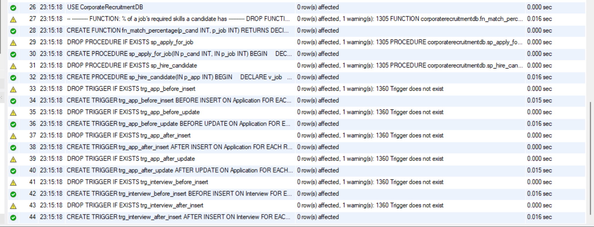
Figure 9: Script 04 output: function, procedures and six triggers created (yellow warnings are DROP … IF EXISTS on the first run)
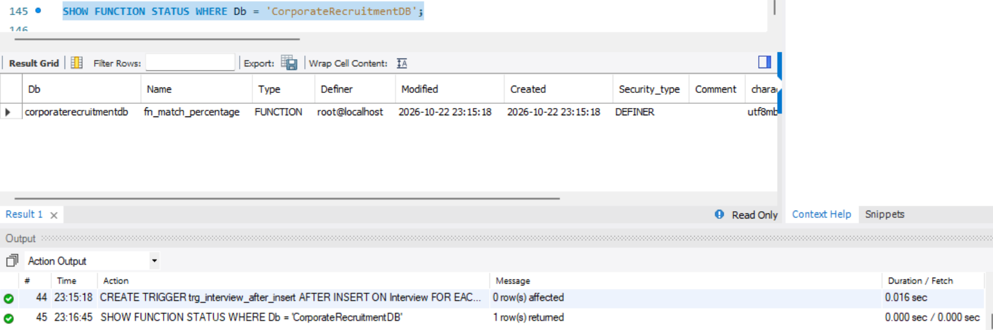
Figure 10: SHOW FUNCTION STATUS: fn_match_percentage
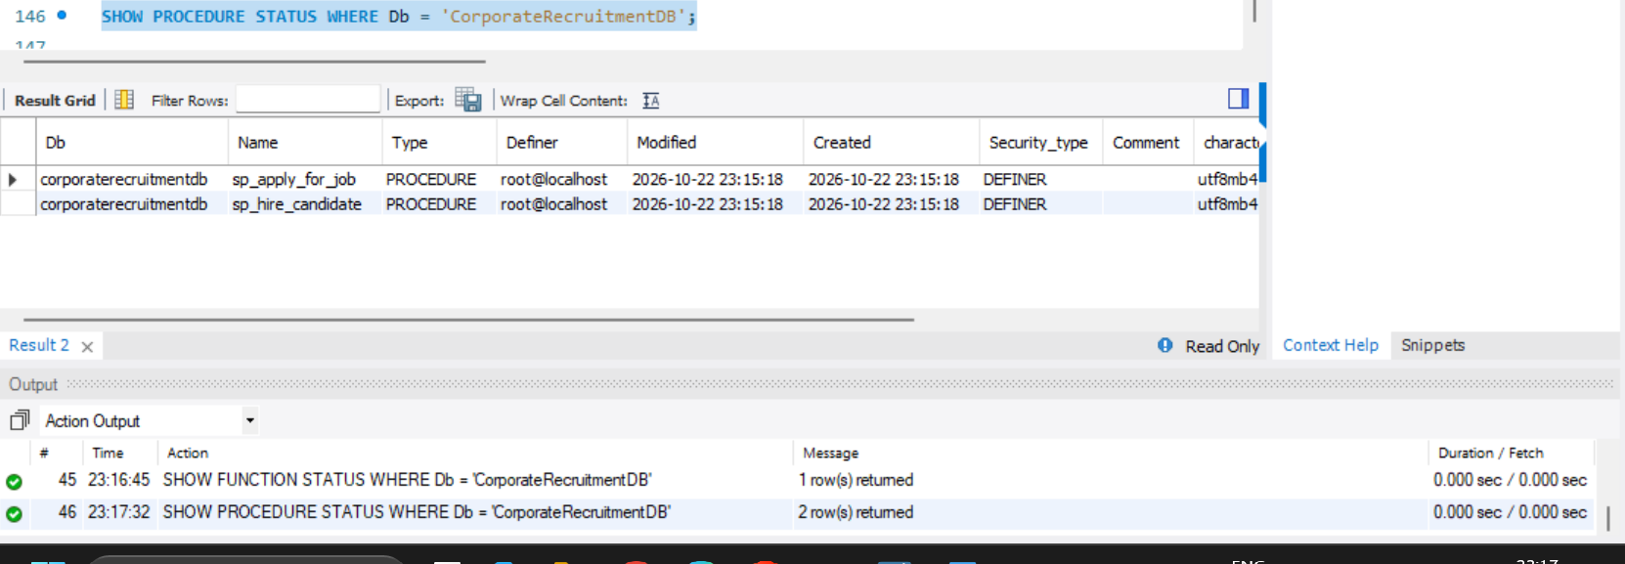
Figure 11: SHOW PROCEDURE STATUS: sp_apply_for_job and sp_hire_candidate
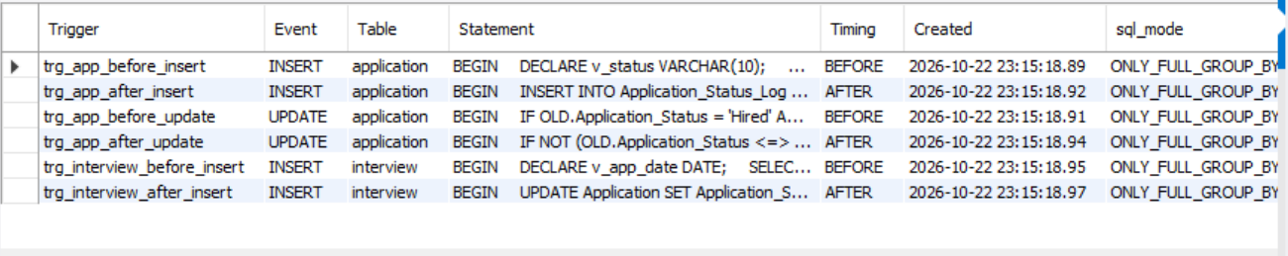
Figure 12: SHOW TRIGGERS: the six triggers on Application and Interview

5.5 Seed data: INSERT and UPDATE (script 05)
Sample data was loaded with INSERT statements: 4 companies, 5 departments, 10 skills, 6 candidates, 7 resumes, 6 jobs with required skills, 18 candidate-skill rows, 8 applications and 2 interviews. UPDATE statements then shortlisted and rejected applications. Because the triggers fire during seeding, the audit log is populated automatically.
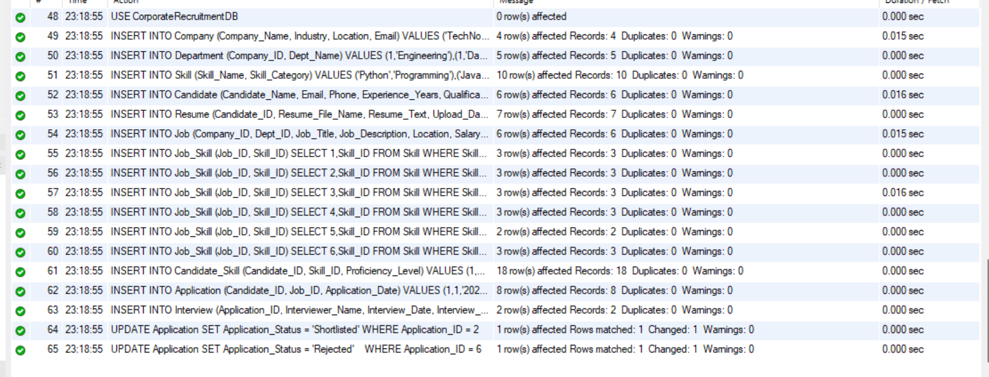
Figure 13: Seed script output: all INSERT and UPDATE statements succeeded
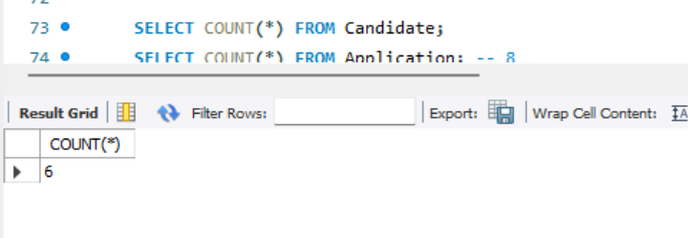
Figure 14: Row count check: 6 candidates
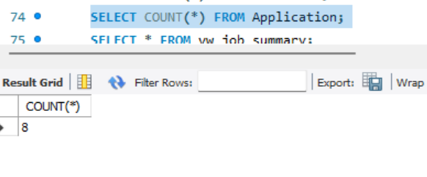
Figure 15: Row count check: 8 applications
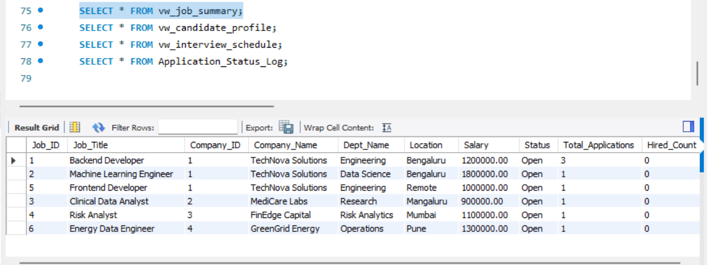
Figure 16: vw_job_summary with seeded data
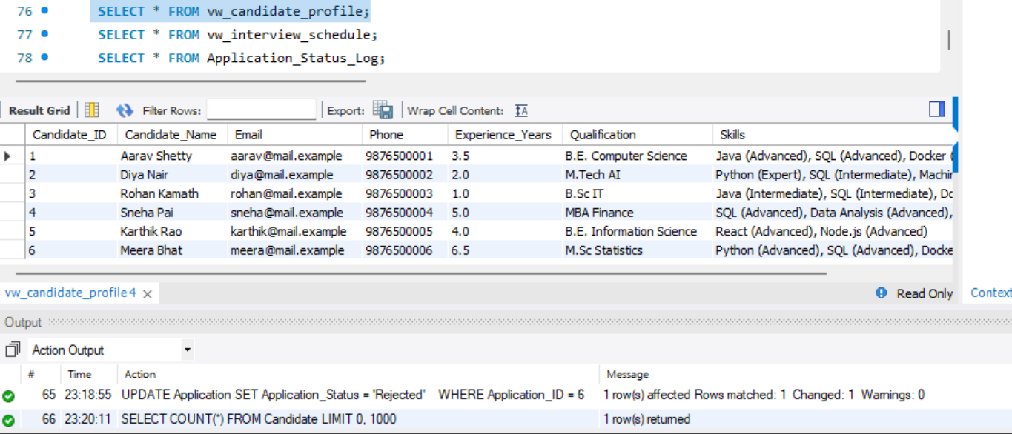
Figure 17: vw_candidate_profile: skills concatenated per candidate
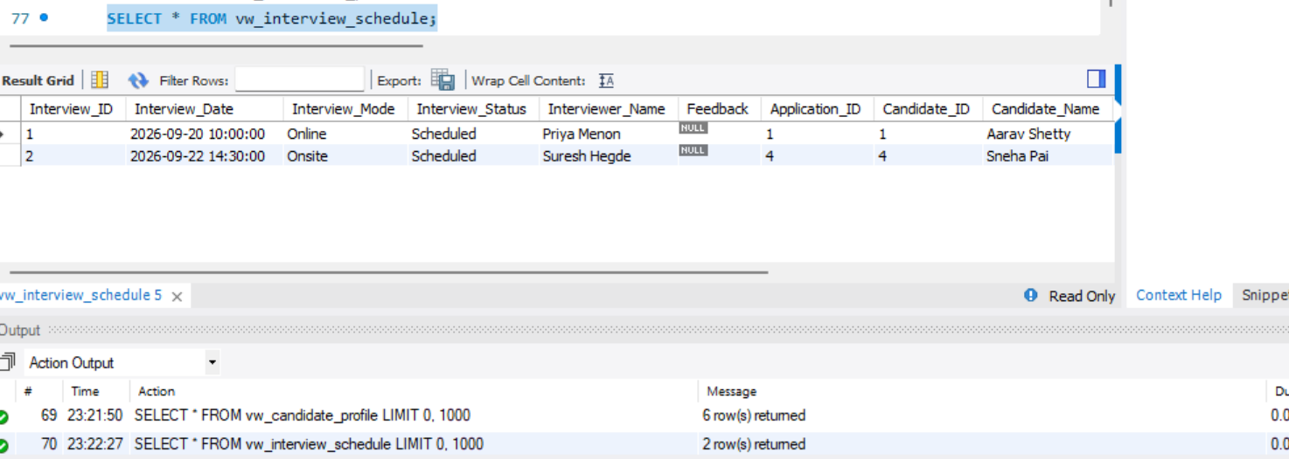
Figure 18: vw_interview_schedule
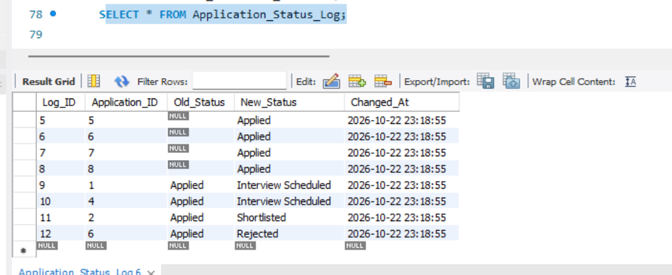
Figure 19: Application_Status_Log filled by triggers during seeding

5.6 Vector database implementation (Qdrant)
Aspect | Design
What is embedded | Resume.Resume_Text (one vector per resume) and Job_Title + Job_Description (one vector per job)
Embedding model | all-MiniLM-L6-v2 (sentence-transformers), 384 dimensions, executed locally with @xenova/transformers (ONNX)
Pre-processing | Text truncated to 2000 characters; mean pooling; vectors L2-normalised
Storage | Qdrant collections resumes (point id = Resume_ID, payload candidate_id, name) and jobs (point id = Job_ID, payload title, company_id)
Index and metric | HNSW index, cosine distance
Retrieval, candidate | Embed the latest resume (or a typed query), take the top 10 jobs, filter Status = Open in MySQL, add fn_match_percentage
Retrieval, recruiter | Embed a job description (or typed query), take the top 15 resumes, keep the best score per candidate, join vw_candidate_profile
Consistency | MySQL is the source of truth. New resumes and jobs are indexed on insert; npm run index:vectors rebuilds the index

export async function ensureCollections() {
const { collections } = await client.getCollections();
for (const name of ['resumes', 'jobs'])
if (!collections.find((c) => c.name === name))
await client.createCollection(name, { vectors: { size: 384, distance: 'Cosine' }
});
}
export async function embed(text) {
extractor ||= await pipeline('feature-extraction', 'Xenova/all-MiniLM-L6-v2');
const out = await extractor(text.slice(0, 2000), { pooling: 'mean', normalize: true
});
return Array.from(out.data);
}

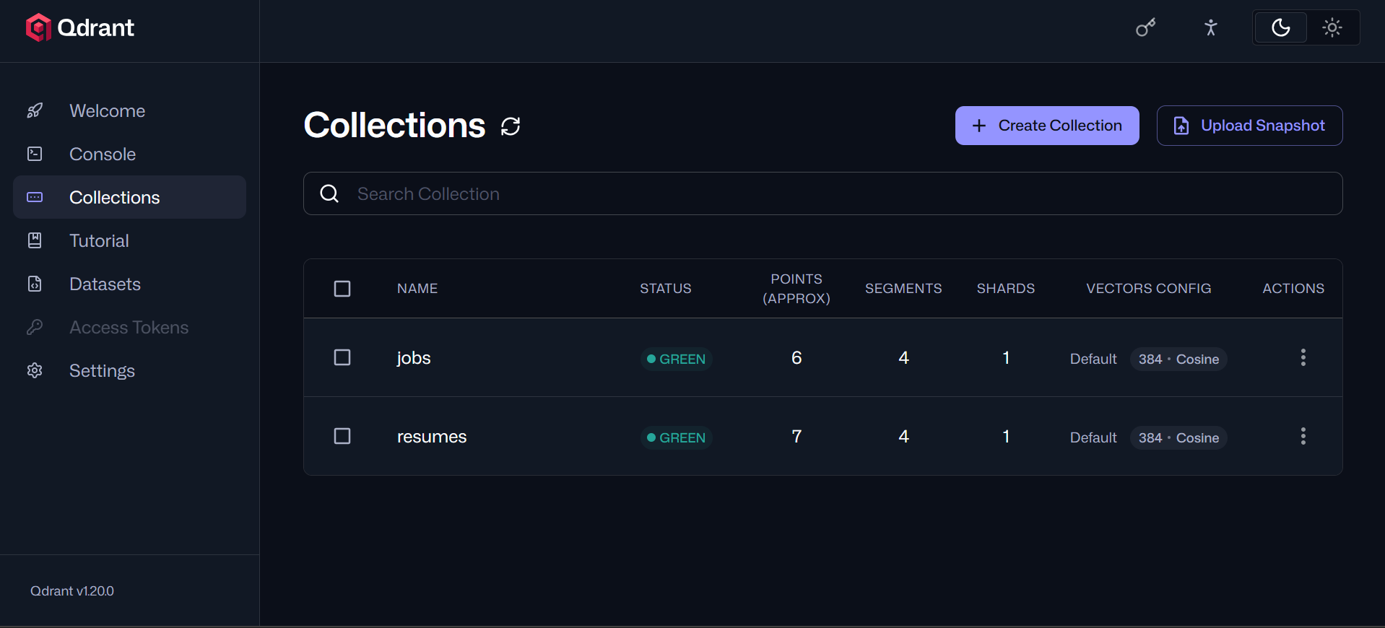
Figure 20: Qdrant dashboard: collections jobs (6 points) and resumes (7 points), 384-dimension cosine vectors

5.7 Advanced database features demonstrated
Concept | Where
Transactions and locking | sp_hire_candidate (FOR UPDATE, rollback handler); sp_apply_for_job; job posting and candidate registration use transactions in the API
Views | vw_job_summary, vw_candidate_profile, vw_interview_schedule
Stored function and procedures | fn_match_percentage, sp_apply_for_job, sp_hire_candidate
Triggers | Six triggers for integrity, audit logging and status automation
Indexing | Composite and single-column indexes on Job, Application, Candidate, Resume, Interview
Full-text search | FULLTEXT indexes ft_job and ft_resume queried with MATCH … AGAINST
Vector similarity search (vector database) | Qdrant cosine search over resume and job embeddings

6. Important Queries
The following queries (script 06) were executed on the seeded database. They cover joins, grouping, aggregation, subqueries, set-based division, full-text search, views, stored routines and DML inside a transaction.

Q1: Four-table JOIN
Lists every application with candidate, job and company.
SELECT a.Application_ID, ca.Candidate_Name, j.Job_Title, c.Company_Name,
a.Application_Status
FROM Application a
JOIN Candidate ca ON ca.Candidate_ID = a.Candidate_ID
JOIN Job j ON j.Job_ID = a.Job_ID
JOIN Company c ON c.Company_ID = j.Company_ID
ORDER BY a.Application_Date DESC;

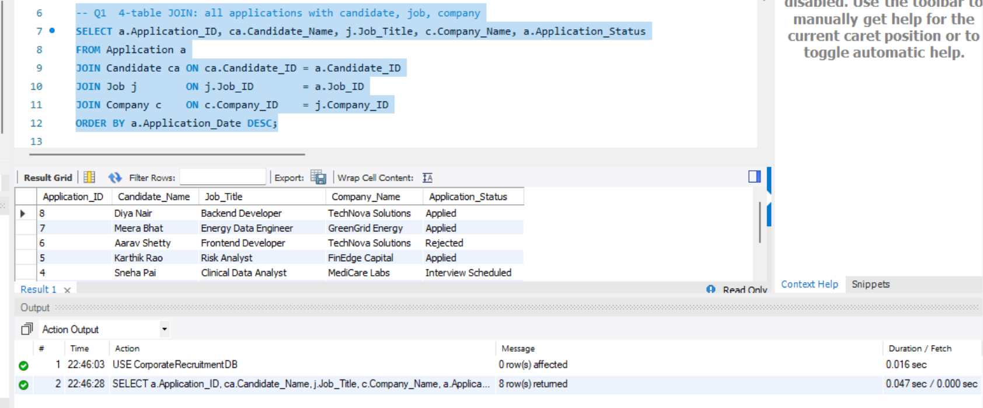
Figure 21: Q1 result

Q2: GROUP BY with HAVING
Jobs that received two or more applications.
SELECT j.Job_Title, COUNT(*) AS applicants
FROM Application a JOIN Job j ON j.Job_ID = a.Job_ID
GROUP BY j.Job_ID, j.Job_Title
HAVING COUNT(*) >= 2
ORDER BY applicants DESC;

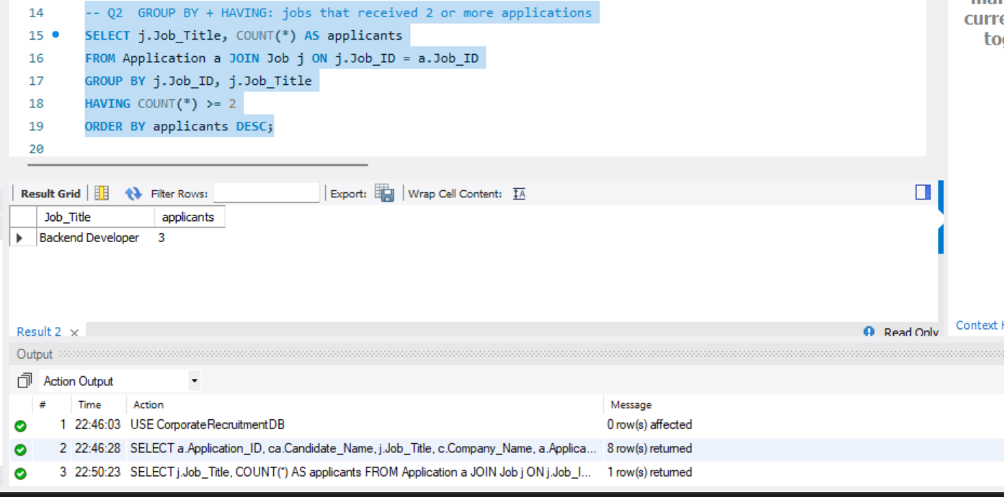
Figure 22: Q2 result

Q3: Aggregate functions
Number of openings, average and maximum salary per industry.
SELECT c.Industry, COUNT(*) AS openings, ROUND(AVG(j.Salary),0) AS avg_salary,
MAX(j.Salary) AS max_salary
FROM Job j JOIN Company c ON c.Company_ID = j.Company_ID
GROUP BY c.Industry ORDER BY avg_salary DESC;

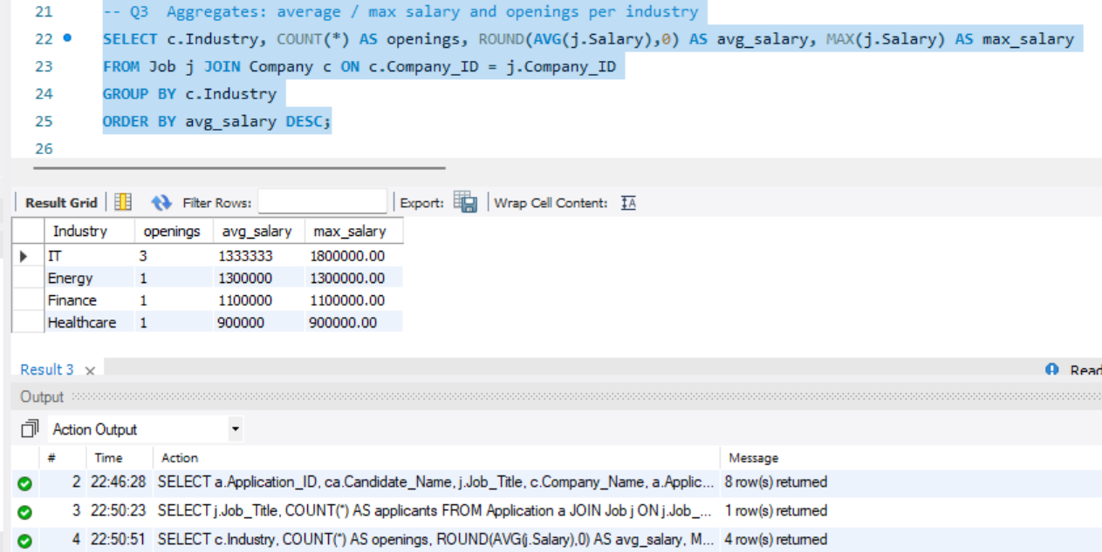
Figure 23: Q3 result

Q4: Scalar subquery
Candidates whose experience is above the overall average.
SELECT Candidate_Name, Experience_Years FROM Candidate
WHERE Experience_Years > (SELECT AVG(Experience_Years) FROM Candidate)
ORDER BY Experience_Years DESC;

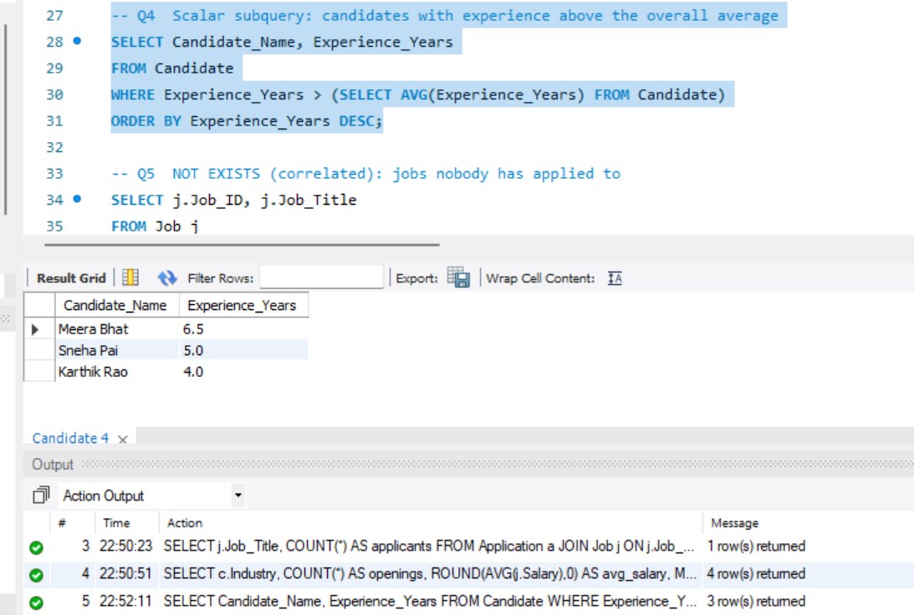
Figure 24: Q4 result

Q5: Correlated subquery with NOT EXISTS
Jobs that nobody has applied to.
SELECT j.Job_ID, j.Job_Title FROM Job j
WHERE NOT EXISTS (SELECT 1 FROM Application a WHERE a.Job_ID = j.Job_ID);

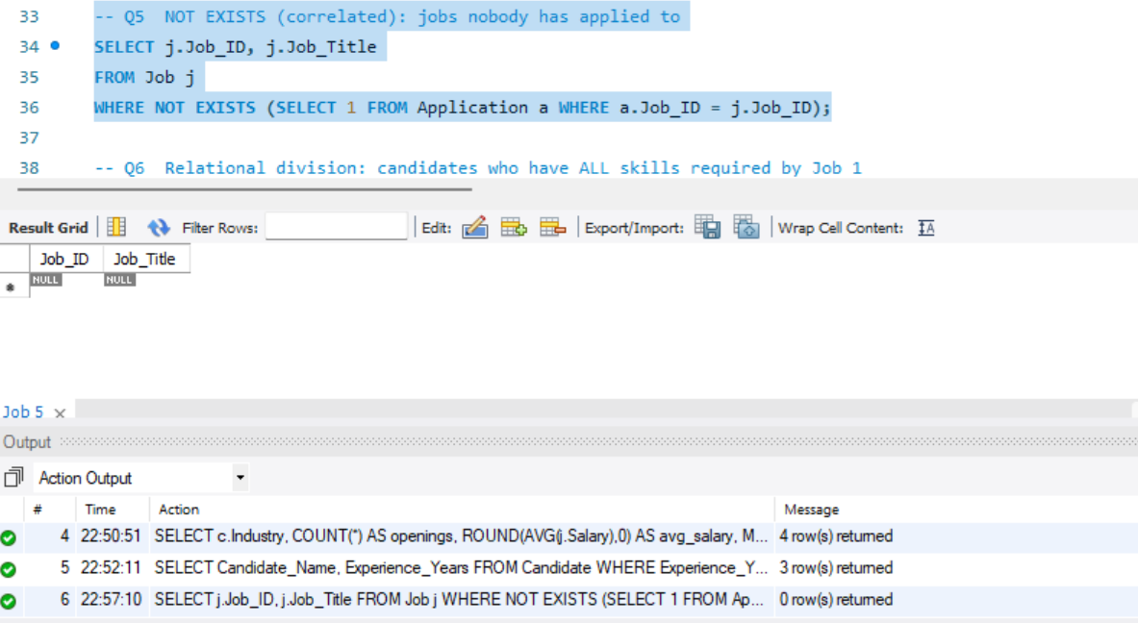
Figure 25: Q5 result

Q6: Relational division
Candidates who possess all skills required by Job 1.
SELECT ca.Candidate_Name
FROM Candidate ca
JOIN Candidate_Skill cs ON cs.Candidate_ID = ca.Candidate_ID
JOIN Job_Skill js ON js.Skill_ID = cs.Skill_ID AND js.Job_ID = 1
GROUP BY ca.Candidate_ID, ca.Candidate_Name
HAVING COUNT(*) = (SELECT COUNT(*) FROM Job_Skill WHERE Job_ID = 1);

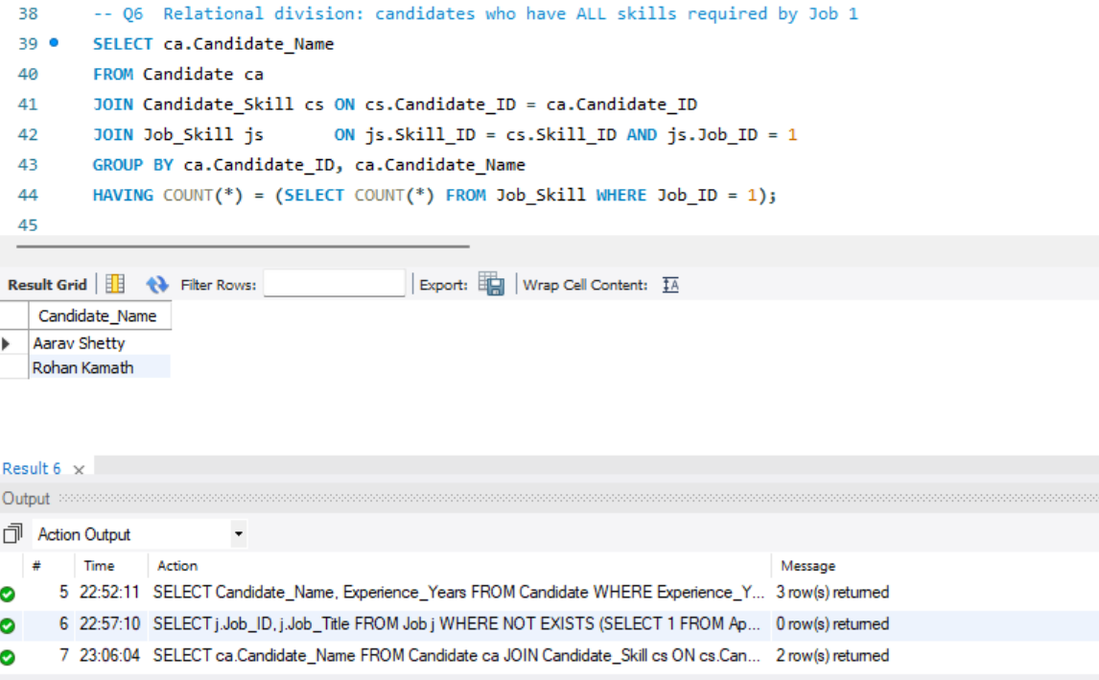
Figure 26: Q6 result

Q7: Stored function in a query
Ranks candidates for Job 2 by skill-match percentage.
SELECT ca.Candidate_Name, fn_match_percentage(ca.Candidate_ID, 2) AS match_pct
FROM Candidate ca
ORDER BY match_pct DESC, ca.Experience_Years DESC LIMIT 5;

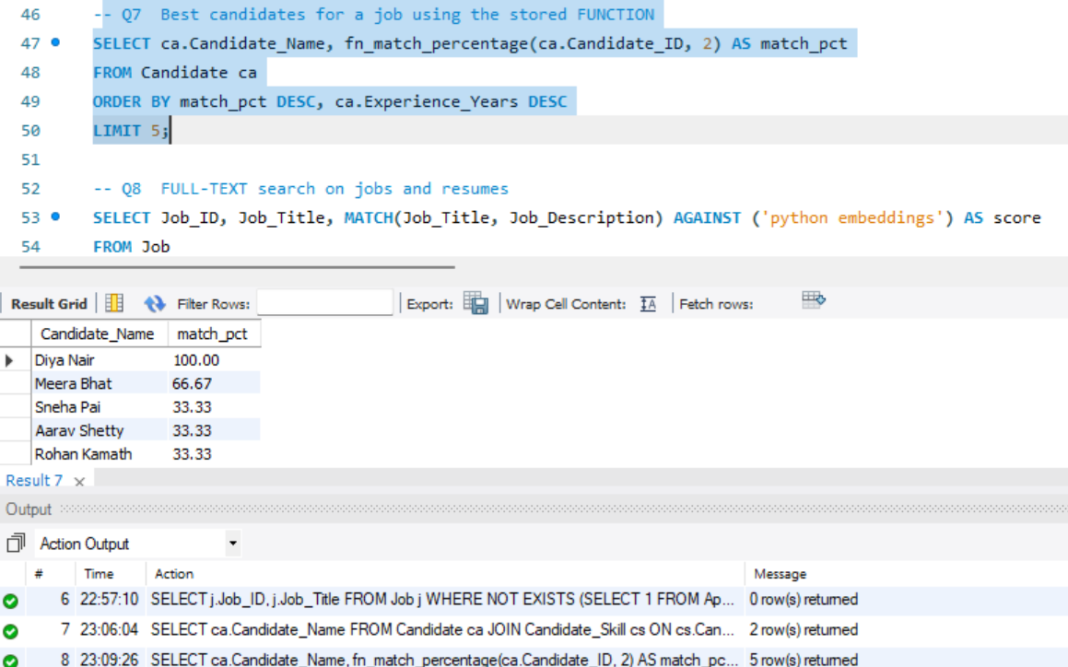
Figure 27: Q7 result

Q8: Full-text search
Natural-language search on jobs and boolean-mode search on resumes.
SELECT Job_ID, Job_Title, MATCH(Job_Title, Job_Description) AGAINST ('python
embeddings') AS score
FROM Job
WHERE MATCH(Job_Title, Job_Description) AGAINST ('python embeddings' IN NATURAL
LANGUAGE MODE)
ORDER BY score DESC;

SELECT Resume_ID, Candidate_ID FROM Resume
WHERE MATCH(Resume_Text) AGAINST ('+Docker +SQL' IN BOOLEAN MODE);

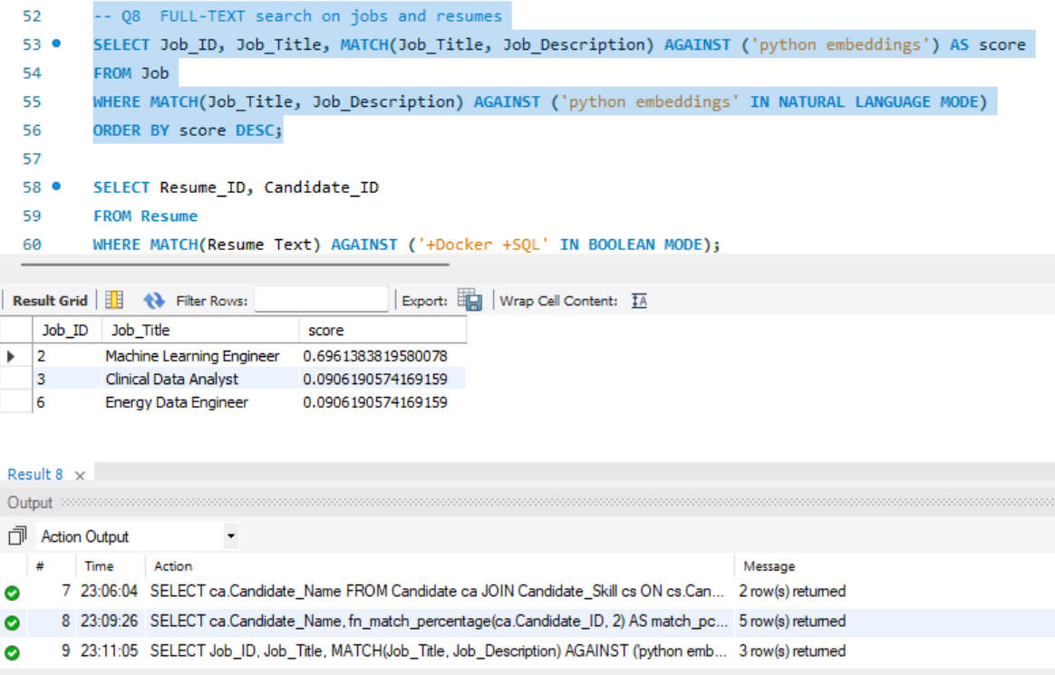
Figure 28: Q8 result: job search
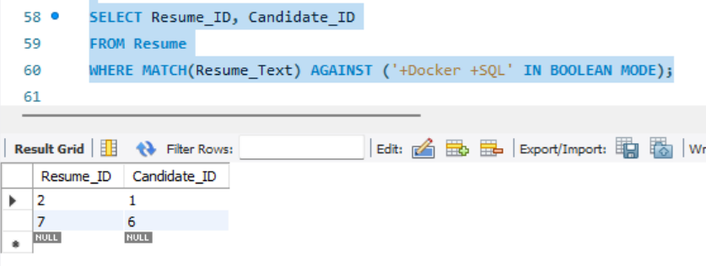
Figure 29: Q8 result: resume search

Q9: Skill demand
Most frequently required skills across all jobs.
SELECT s.Skill_Name, COUNT(*) AS jobs_requiring
FROM Job_Skill js JOIN Skill s ON s.Skill_ID = js.Skill_ID
GROUP BY s.Skill_ID, s.Skill_Name ORDER BY jobs_requiring DESC, s.Skill_Name;

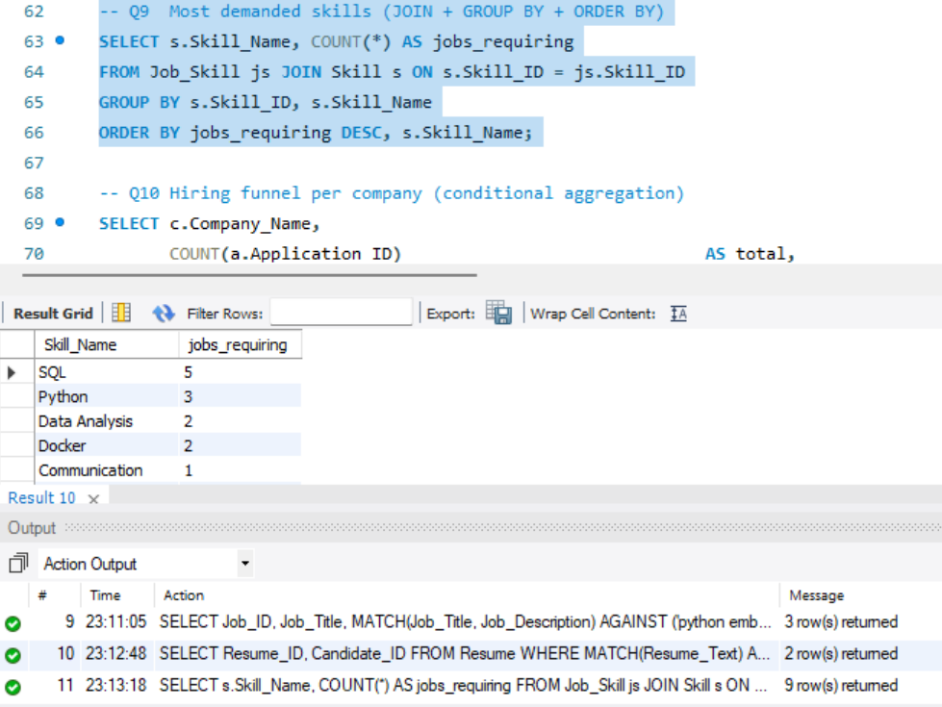
Figure 30: Q9 result

Q10: Hiring funnel with conditional aggregation
Applications, interviews, hires and hire rate per company.
SELECT c.Company_Name, COUNT(a.Application_ID) AS total,
SUM(a.Application_Status = 'Interview Scheduled') AS interviewing,
SUM(a.Application_Status = 'Hired') AS hired,
ROUND(100*SUM(a.Application_Status='Hired')/NULLIF(COUNT(a.Application_ID),0),1) AS hire_rate_pct
FROM Company c
LEFT JOIN Job j ON j.Company_ID = c.Company_ID
LEFT JOIN Application a ON a.Job_ID = j.Job_ID
GROUP BY c.Company_ID, c.Company_Name;

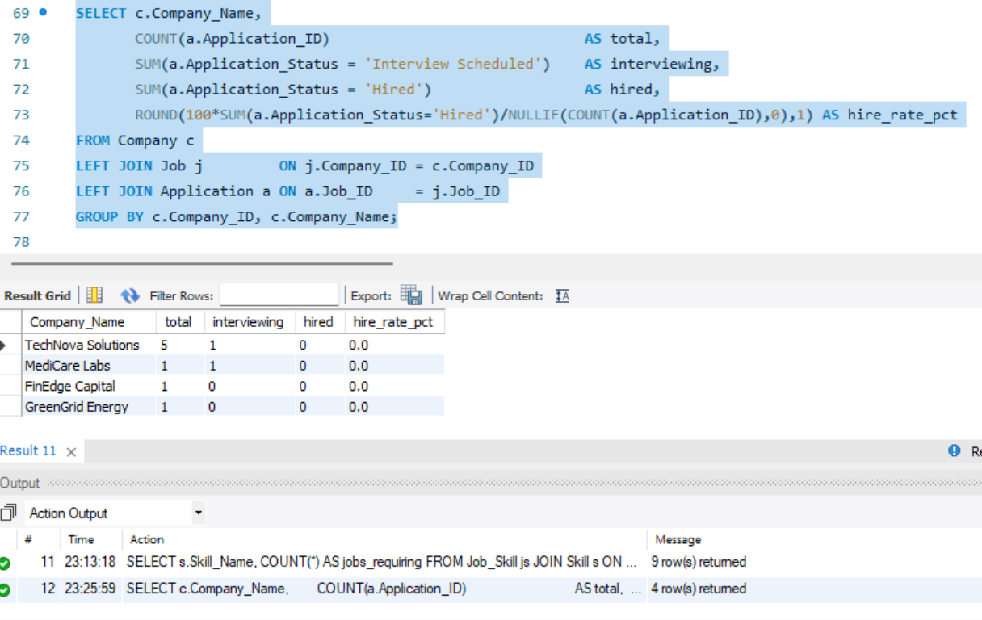
Figure 31: Q10 result

Q11: LEFT JOIN anti-join
Candidates who have never applied.
SELECT ca.Candidate_Name
FROM Candidate ca LEFT JOIN Application a ON a.Candidate_ID = ca.Candidate_ID
WHERE a.Application_ID IS NULL;

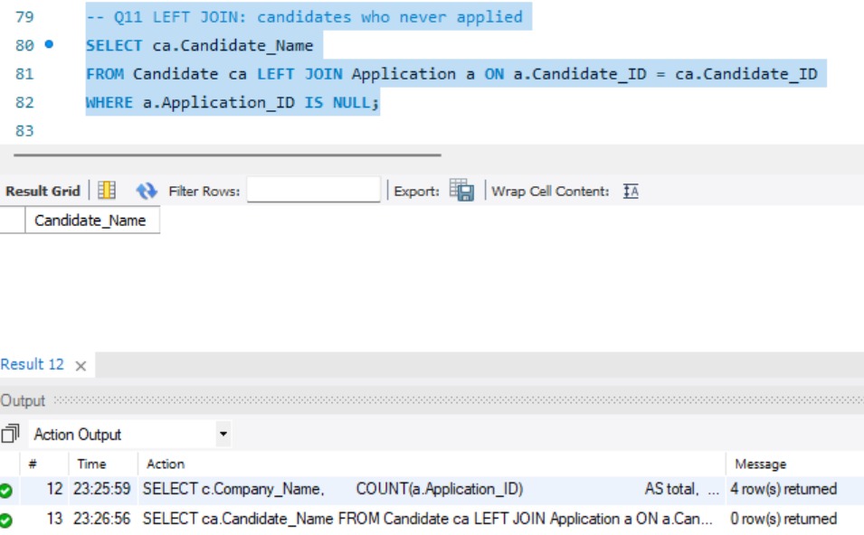
Figure 32: Q11 result

Q12: Querying the views
Views used like ordinary tables.
SELECT * FROM vw_job_summary ORDER BY Total_Applications DESC;
SELECT * FROM vw_candidate_profile WHERE Skills LIKE '%SQL%';
SELECT * FROM vw_interview_schedule;

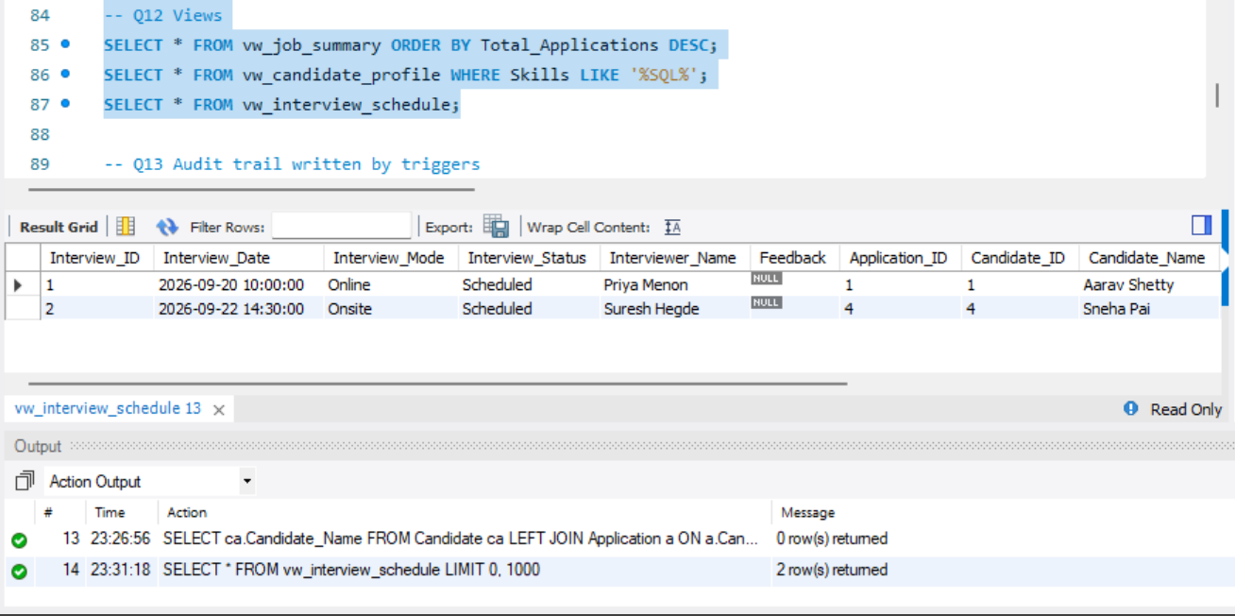
Figure 33: Q12 result

Q13: Audit trail written by triggers
Every status change is recorded without any application code.
SELECT * FROM Application_Status_Log ORDER BY Log_ID DESC LIMIT 10;

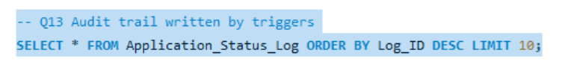
Figure 34: Q13 statement
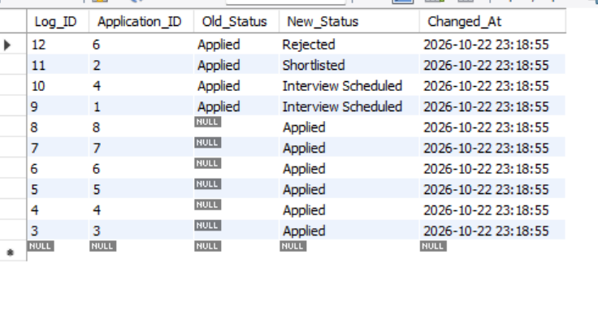
Figure 35: Q13 result

Q14: Stored procedures: apply and hire
A new application is created, then Candidate 1 is hired. The procedure rejects the other applicants and closes the job atomically.
CALL sp_apply_for_job(4, 1);
CALL sp_hire_candidate(1);
SELECT Application_ID, Application_Status FROM Application WHERE Job_ID = 1;
SELECT Job_ID, Status FROM Job WHERE Job_ID = 1;

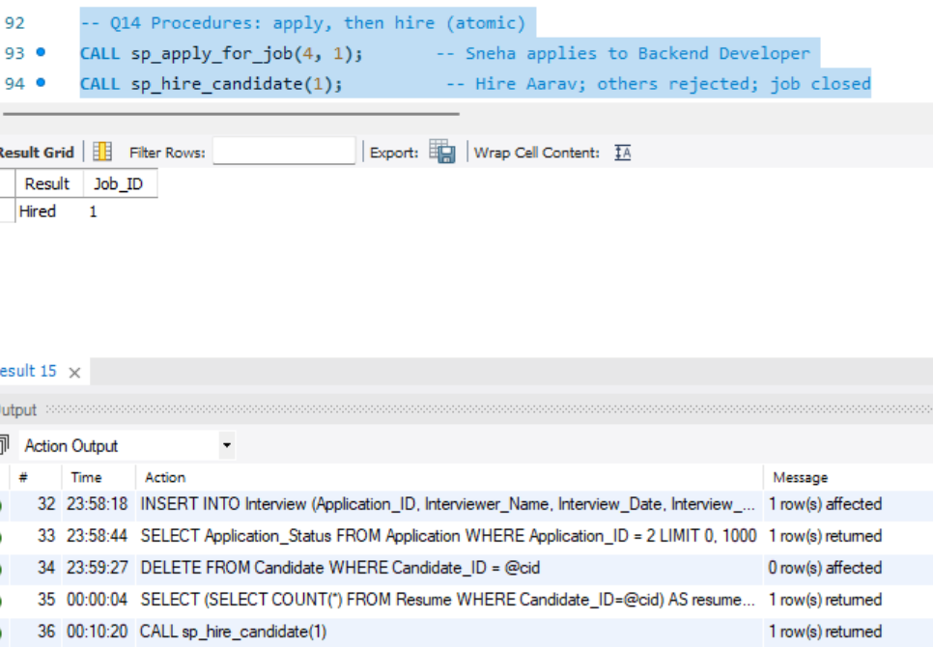
Figure 36: Q14: statuses of all applications to Job 1 after hiring
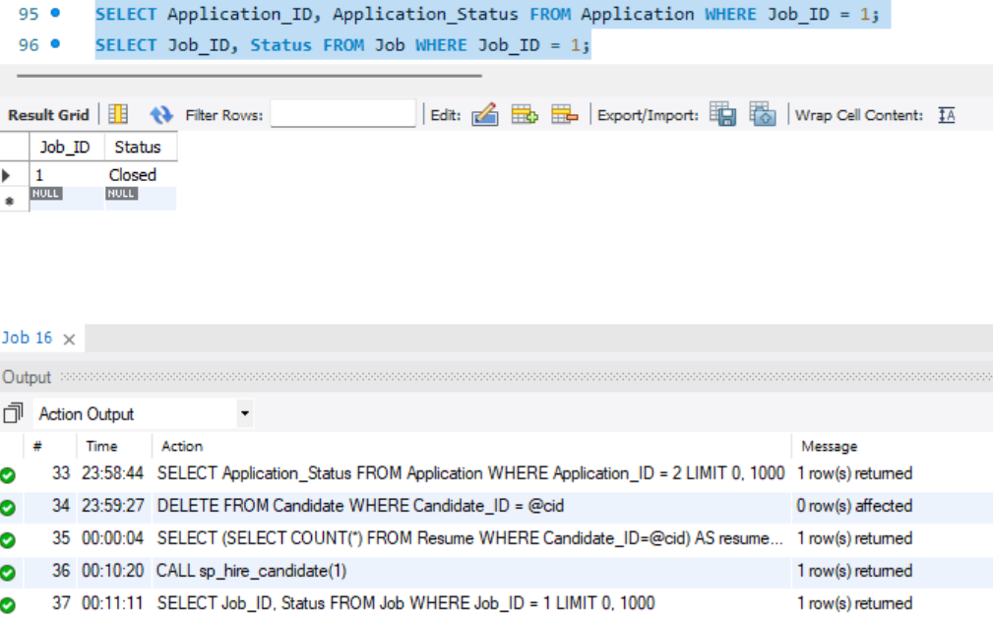
Figure 37: Q14: Job 1 is now Closed

Q15: INSERT, UPDATE and DELETE inside a transaction
Demonstrates DML and rollback; the seed data is left untouched.
START TRANSACTION;
INSERT INTO Skill (Skill_Name, Skill_Category) VALUES ('Kubernetes','DevOps');
UPDATE Candidate SET Experience_Years = Experience_Years + 1 WHERE Candidate_ID = 3;
DELETE FROM Skill WHERE Skill_Name = 'Kubernetes';
ROLLBACK;

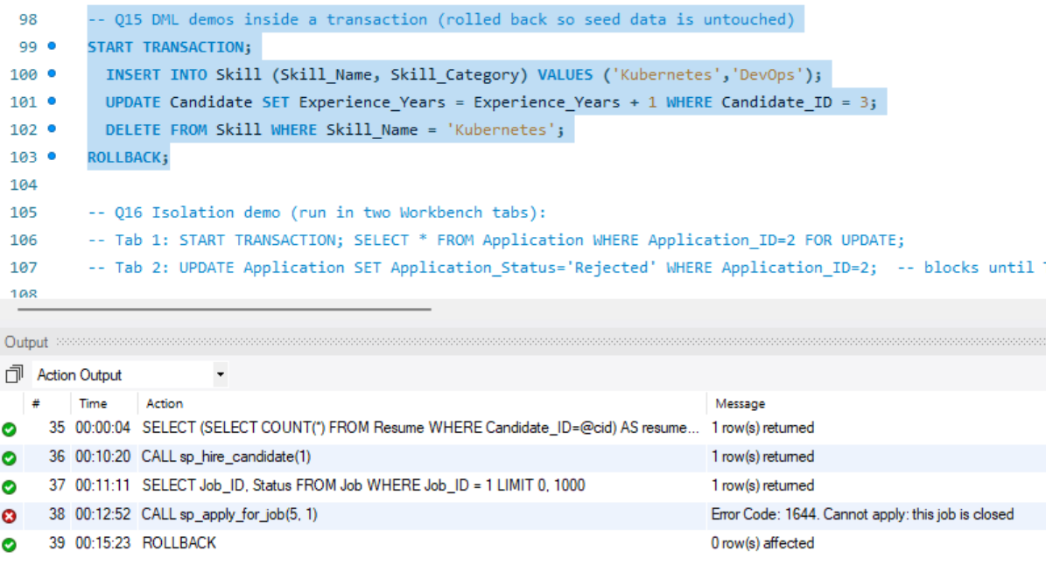
Figure 38: Q15 output: all statements ran, then ROLLBACK

7. System Architecture
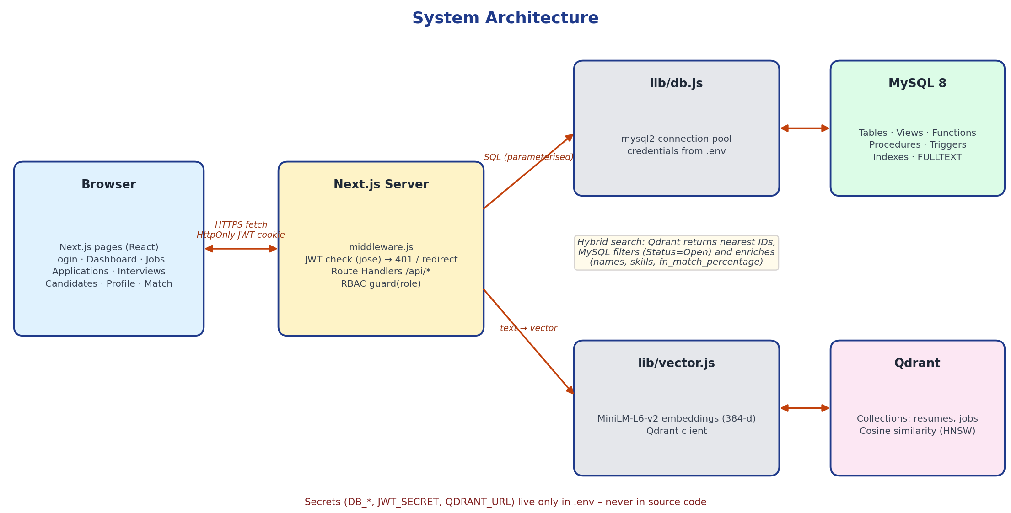
Figure 39: System architecture: browser, Next.js server, MySQL and Qdrant

7.1 Components
Component | Responsibility
Browser (React pages) | Login, dashboard, jobs, applications, interviews, candidates, profile, semantic match
middleware.js | Verifies the JWT cookie on every page and API request; returns 401 or redirects to /login
Route Handlers (/api/*) | Business logic; each handler calls guard(role) for role-based access and uses parameterised SQL only
lib/db.js | mysql2 connection pool configured from environment variables
lib/vector.js | Local embedding model and Qdrant client
MySQL 8 | Tables, constraints, views, function, procedures, triggers, indexes
Qdrant | Vector index of resumes and jobs

7.2 API endpoints
Method | Endpoint | Roles | Purpose
POST | /api/auth/login, /logout | All | Authenticate (bcrypt compare) and set an HttpOnly JWT cookie
POST | /api/auth/register | Public | Create Candidate and Users rows in one transaction
GET / POST | /api/jobs | All / Recruiter | Full-text, location, type and salary search with skill-match; post a job with skills
PATCH / DELETE | /api/jobs/[id] | Recruiter, Admin | Close or reopen a job; delete (Admin only)
GET / POST / PATCH | /api/applications | Role-scoped | List; apply (calls sp_apply_for_job); change status
POST | /api/applications/hire | Recruiter, Admin | Calls sp_hire_candidate (transaction)
GET / POST / PATCH | /api/interviews | Role-scoped | View vw_interview_schedule; schedule; complete or cancel
GET | /api/candidates | Recruiter, Admin | Filter vw_candidate_profile by skill and experience
GET / POST | /api/profile | Candidate | Profile, skills, resume upload (also indexed in Qdrant)
GET | /api/search/semantic | Role-aware | Vector search in Qdrant enriched from MySQL
GET | /api/dashboard | Recruiter, Admin | Aggregate queries and views

7.3 Authentication, authorisation and configuration
- Authentication: passwords are stored as bcrypt hashes (cost 10). A successful login issues a signed JWT (8 hours) in an HttpOnly, SameSite cookie, so scripts in the browser cannot read it.
- Authorisation: three roles. Recruiters only see and change data of their own company; candidates only see their own applications and interviews.
- SQL injection: every query uses placeholders; no user input is concatenated into SQL.
- Configuration: DB_HOST, DB_PORT, DB_USER, DB_PASSWORD, DB_NAME, JWT_SECRET and QDRANT_URL are read from the .env file, which is excluded from Git. Nothing sensitive is hard-coded.
Capability | Admin | Recruiter | Candidate
View all companies’ data | Yes | Own company | Own data
Post, close, reopen jobs | Close / reopen | Own company | No
Delete a job | Yes | No | No
Apply to a job | No | No | Yes
Change status, schedule interviews, hire | Yes | Own company | No
Dashboard and candidate list | Yes | Yes | No
Edit profile, skills, resumes | No | No | Yes
Recommended jobs (semantic) | — | — | Yes
Matching candidates (semantic) | Yes | Yes | No

8. Application Screenshots

8.1 Setup and login
Demo accounts are created by a script that stores only bcrypt hashes in the Users table.
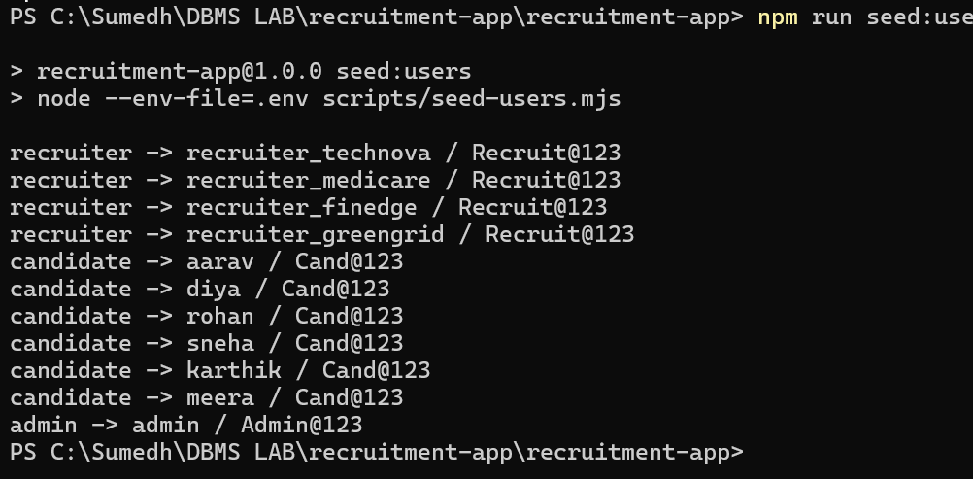
Figure 40: npm run seed:users: recruiter, candidate and admin accounts created
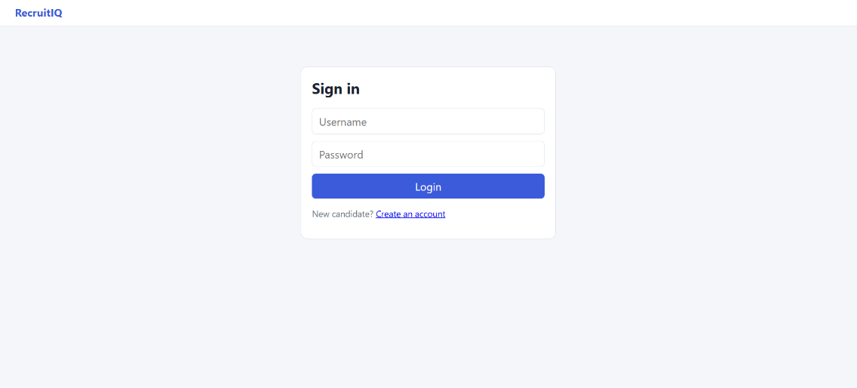
Figure 41: Login page

8.2 Recruiter flow
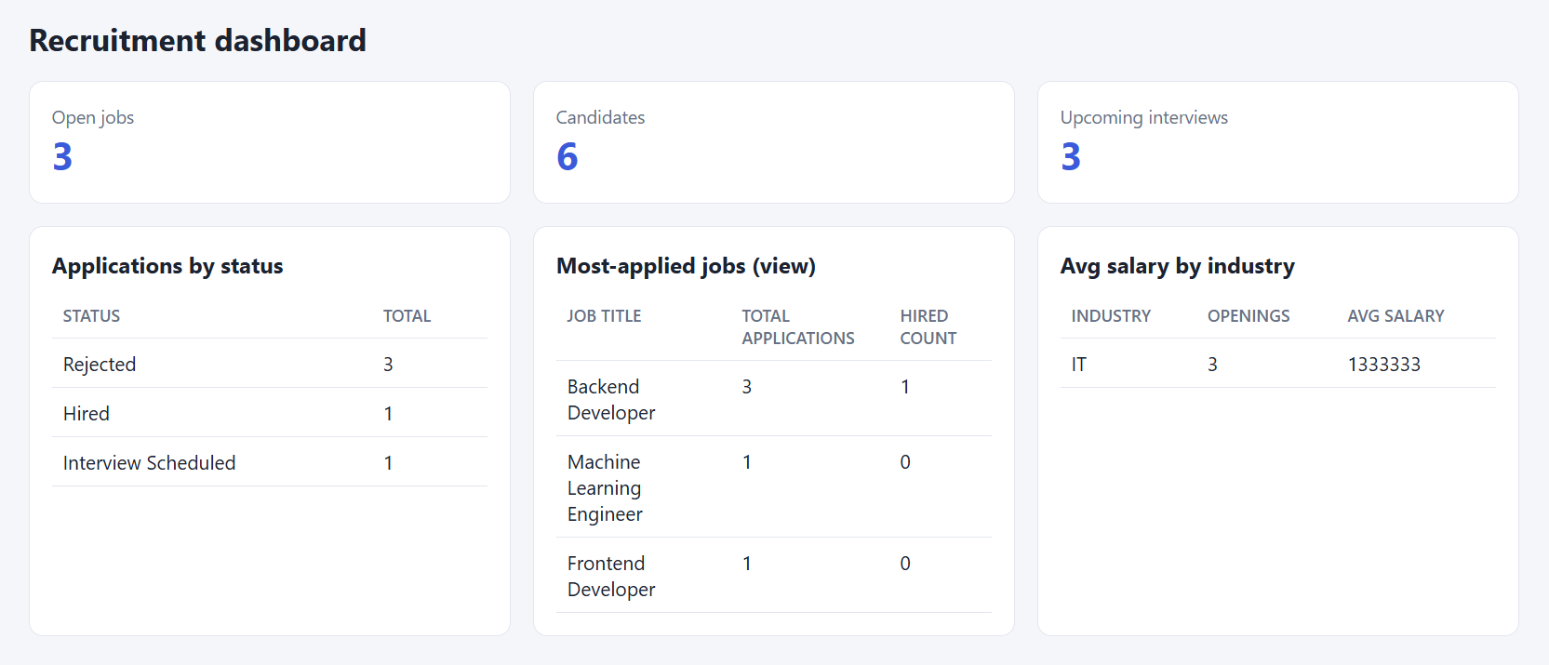
Figure 42: Recruiter dashboard: totals and applications by status
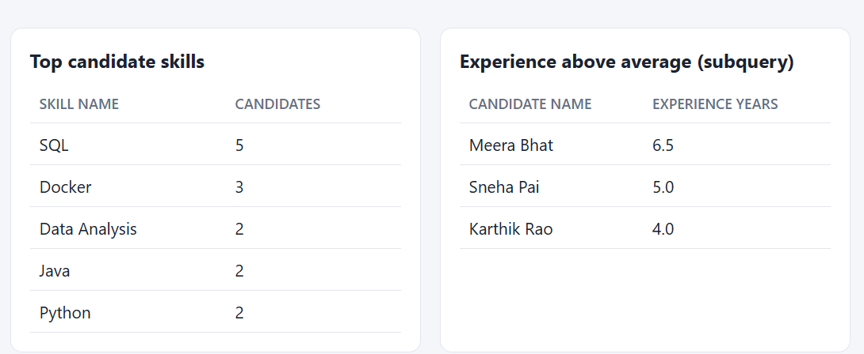
Figure 43: Recruiter dashboard: most-applied jobs (from vw_job_summary), average salary by industry, top skills
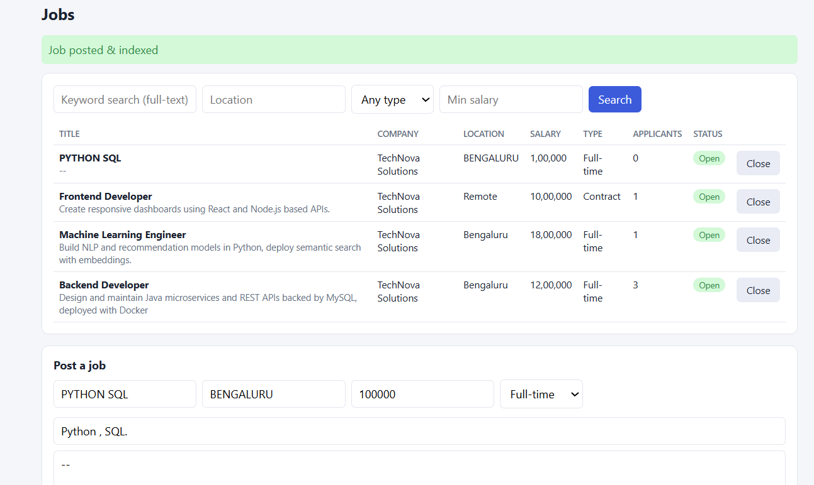
Figure 44: Posting a new job with required skills (job and Job_Skill rows inserted in one transaction, then indexed in Qdrant)
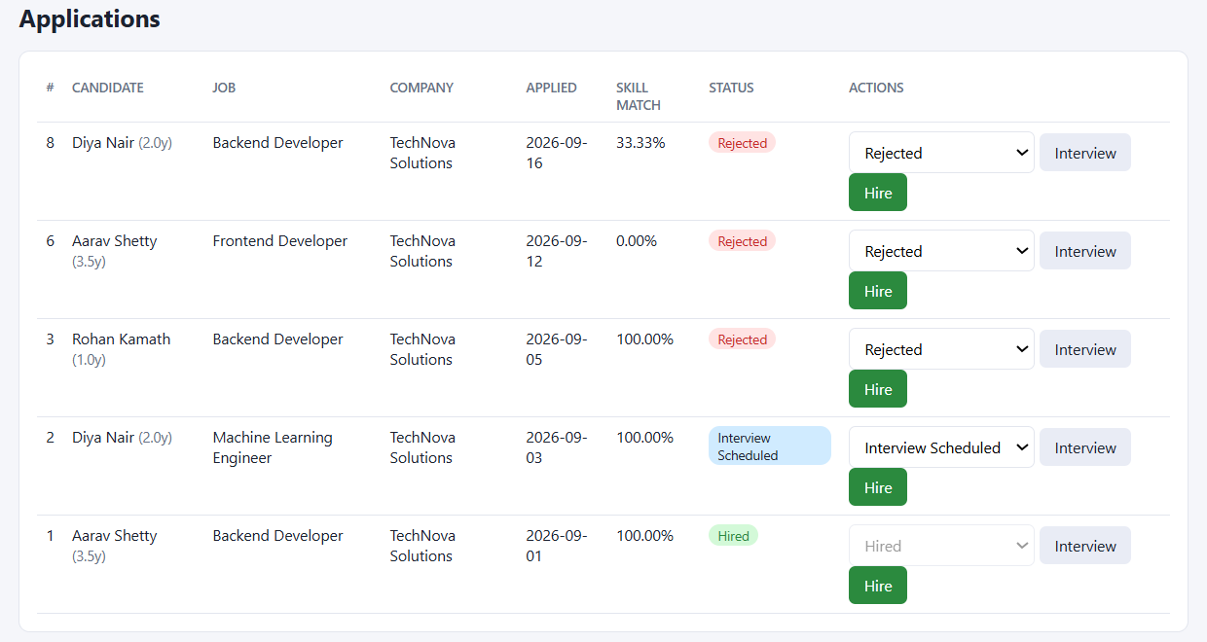
Figure 45: Applications screen with status, skill-match percentage and actions
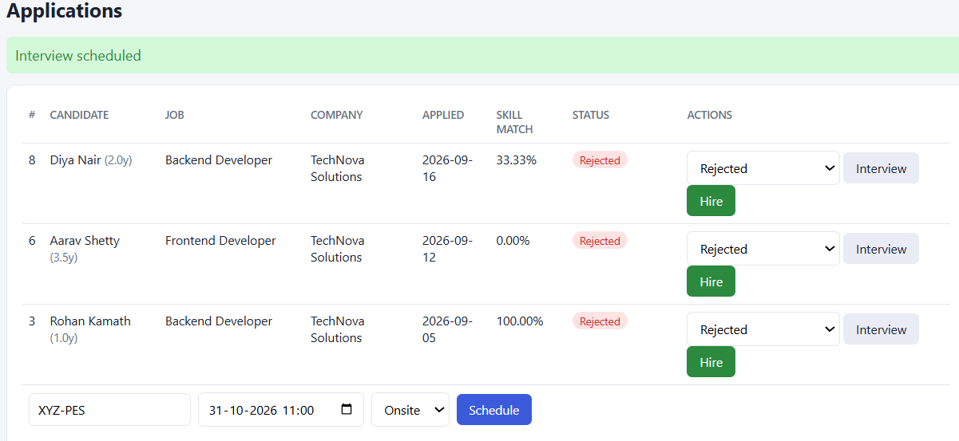
Figure 46: Scheduling an interview for an application
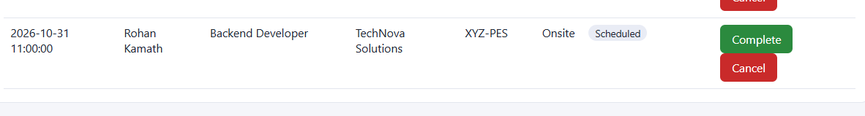
Figure 47: Interview schedule page
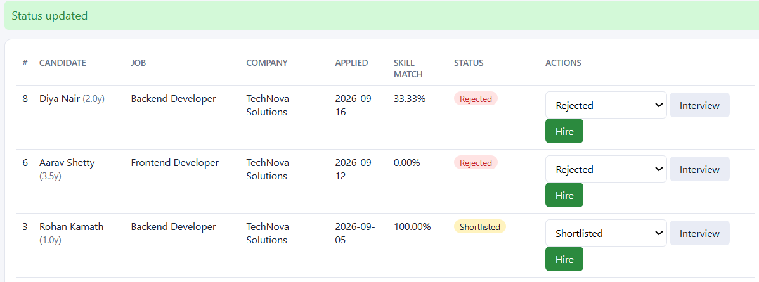
Figure 48: Status changed to Shortlisted; the trigger records the change in the audit log
Figure 49: Candidate hired through sp_hire_candidate
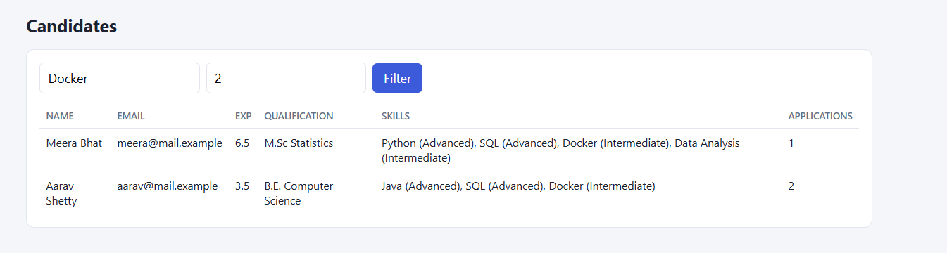
Figure 50: Filtering candidates by skill and experience

8.3 Candidate flow
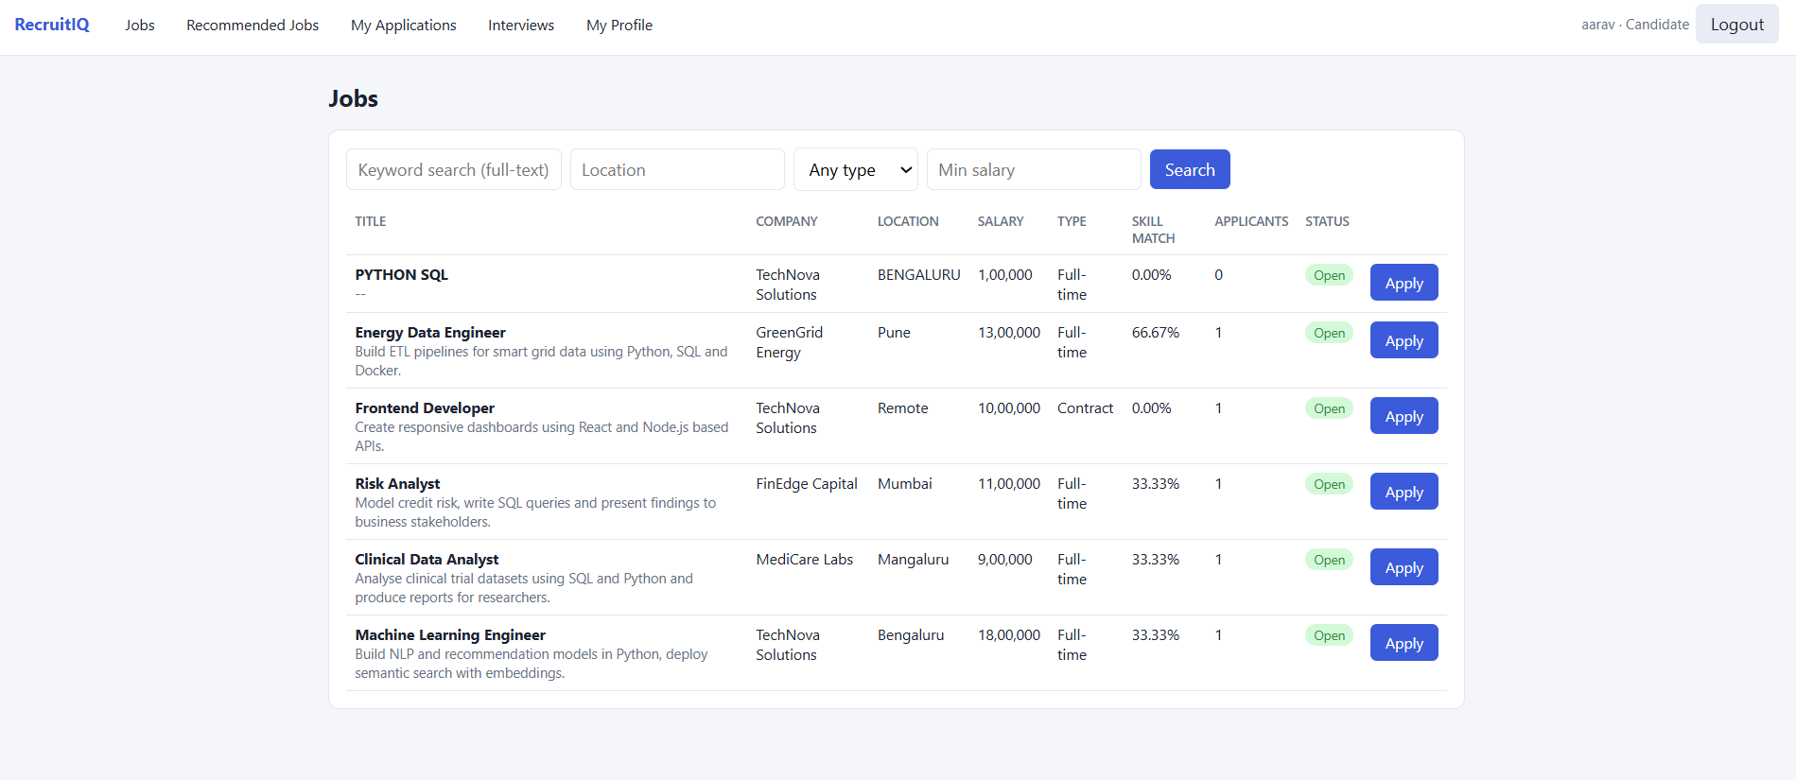
Figure 51: Jobs a candidate can apply to, with the skill-match percentage from fn_match_percentage
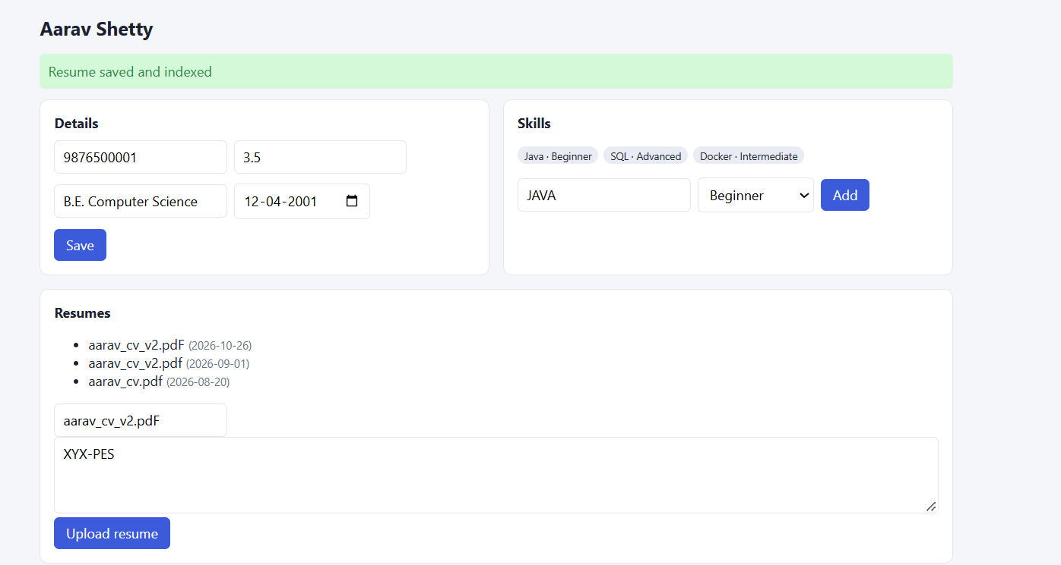
Figure 52: Candidate profile: details, skills and resume upload
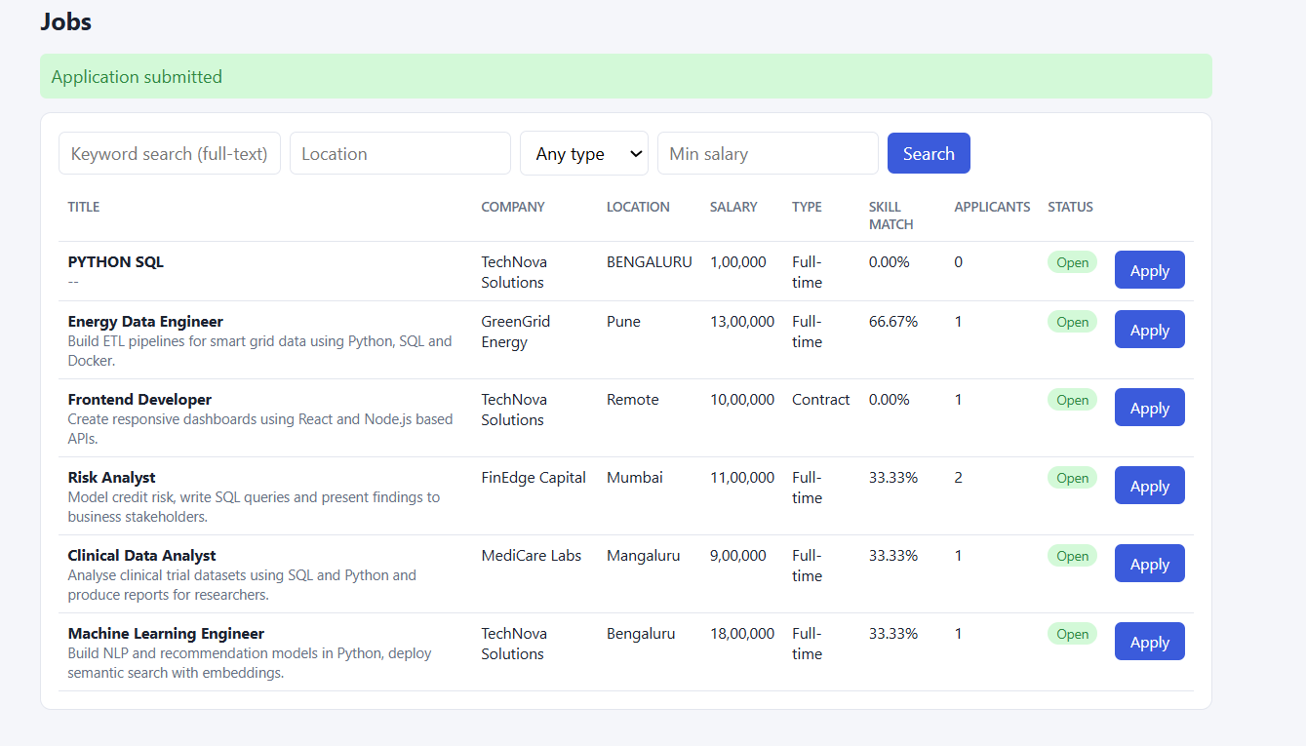
Figure 53: Applying to a job: application submitted
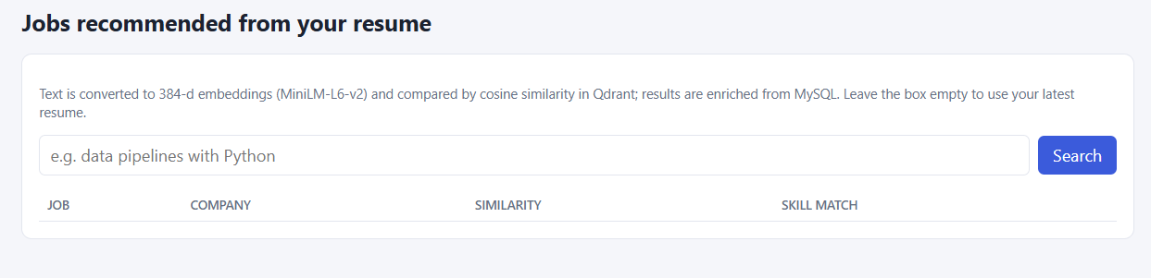
Figure 54: Recommended Jobs page (semantic search over the candidate’s resume)
Add here: screenshot of the semantic search results (Recruiter: Semantic Match with a job selected; Candidate: Recommended Jobs after pressing Search).
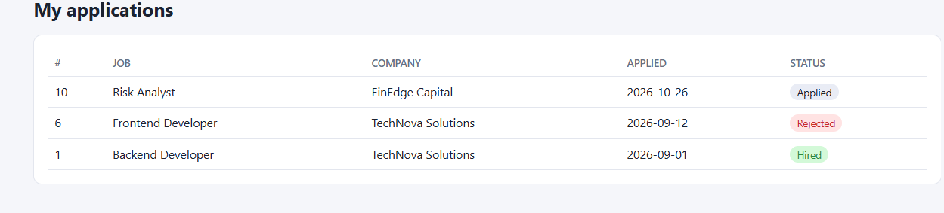
Figure 55: My applications

8.4 Security checks
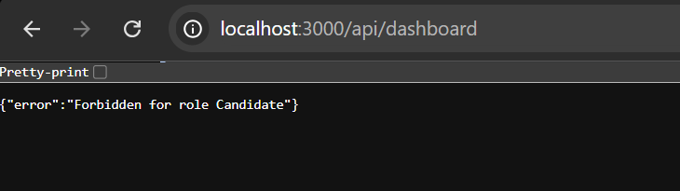
Figure 56: A candidate calling a recruiter-only API receives 403 Forbidden
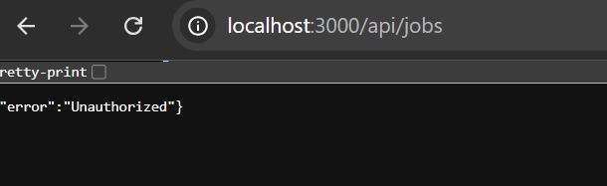
Figure 57: A logged-out request to a protected API receives 401 Unauthorized

9. Testing Results
Database-level tests were executed from MySQL Workbench (script 07). Negative tests are expected to fail with the stated error; positive tests must succeed. Application-level tests were executed in the browser.

9.1 Summary of test cases
ID | Test | Expected | Actual | Result
T1 | Candidate inserted without a name | Rejected (NOT NULL) | Error 1364: Candidate_Name has no default value | Pass
T2 | Duplicate candidate email | Rejected (UNIQUE) | Error 1062: duplicate entry for key candidate.Email | Pass
T3 | Negative experience | Rejected (CHECK) | Error 3819: CHK_Experience violated | Pass
T4 | Phone shorter than 10 characters | Rejected (CHECK) | Error 3819: CHK_Phone violated | Pass
T5 | Negative salary | Rejected (CHECK) | Error 3819: CHK_Salary violated | Pass
T6 | Invalid job type | Rejected (CHECK) | Error 3819: CHK_Job_Type violated | Pass
T7 | Job for a non-existent company | Rejected (FK) | Error 1452: foreign key constraint fails | Pass
T8 | Same candidate applies twice to a job | Rejected (UNIQUE) | Error 1062: duplicate entry for UQ_Candidate_Job | Pass
T9 | Invalid application status | Rejected (CHECK) | Error 3819: CHK_App_Status violated | Pass
T10 | Apply without a resume | Rejected (trigger) | Error 1644: Upload a resume before applying | Pass
T11 | Interview dated before the application | Rejected (trigger) | Error 1644: Interview date cannot be before application date | Pass
T12 | Delete a company that has jobs | Rejected (FK RESTRICT) | Error 1451: cannot delete a parent row | Pass
T13 | Hire an application that is only Applied | Rejected, nothing changed | Error 1644: Only shortlisted / interviewed applications can be hired | Pass
T14 | Apply to a closed job | Rejected (trigger) | Error 1644: Cannot apply: this job is closed | Pass
P1 | Schedule an interview | Application moves to Interview Scheduled | Status of Application 2 became Interview Scheduled; log row added | Pass
P2 | Delete a candidate (ON DELETE CASCADE) | Resumes and skills removed | Counts returned 0 and 0; the DELETE affected 0 rows because @cid was not set | Re-run
P3 | Hire through sp_hire_candidate | Hired; others Rejected; job Closed | Application 1 Hired, Applications 3 and 8 Rejected, Job 1 Closed; 3 audit rows | Pass
A1 | Candidate calls the dashboard API | 403 Forbidden | Forbidden for role Candidate | Pass
A2 | Recruiter changes another company’s application | 404 Not found | Screenshot to be added | Pending
A3 | Logged-out request to a protected API | 401 Unauthorized | Unauthorized | Pass
A4 | Login with a wrong password | 401 Invalid credentials | Screenshot to be added | Pending
V1 | Recruiter semantic search “NLP recommendation” | Machine-learning resume ranked first | Screenshot to be added | Pending
V2 | Candidate Recommended Jobs from latest resume | Best-matching jobs on top | Screenshot to be added | Pending

Outcome: all 14 negative database tests were rejected with the intended error, and the integrity checks and triggers behave as designed. The remaining items marked Pending or Re-run need a screenshot or a repeat run before final submission.

9.2 Evidence: negative tests (T1 to T14)
Each pair shows the statement executed and the error returned by MySQL.

T1
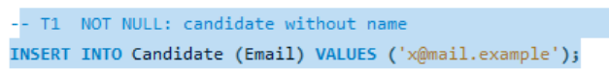
Figure 58: T1: statement
Figure 59: T1: error returned

T2
Figure 60: T2: statement
Figure 61: T2: error returned

T3
Figure 62: T3: statement
Figure 63: T3: error returned

T4
Figure 64: T4: statement
Figure 65: T4: error returned

T5
Figure 66: T5: statement
Figure 67: T5: error returned

T6
Figure 68: T6: statement
Figure 69: T6: error returned

T7
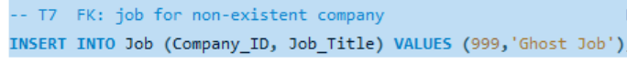
Figure 70: T7: statement
Figure 71: T7: error returned

T8
Figure 72: T8: statement
Figure 73: T8: error returned

T9
Figure 74: T9: statement
Figure 75: T9: error returned

T10
Figure 76: T10: a candidate without any resume is inserted (succeeds)
Figure 77: T10: insert output
Figure 78: T10: application for that candidate
Figure 79: T10: trigger error – resume required

T11
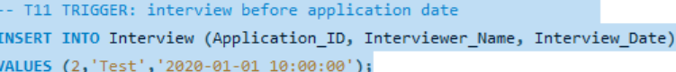
Figure 80: T11: statement
Figure 81: T11: error returned

T12

Figure 82: T12: statement
Figure 83: T12: error returned

T13
Figure 84: T13: statement
Figure 85: T13: error returned

T14
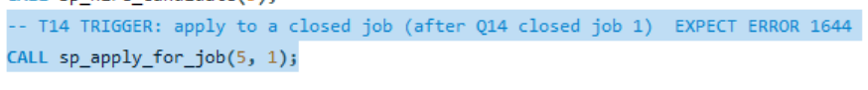
Figure 86: T14: statement
Figure 87: T14: error returned

9.3 Evidence: positive tests and audit log

P1: interview scheduling advances the application
Figure 88: P1: INSERT INTO Interview
Figure 89: P1: output
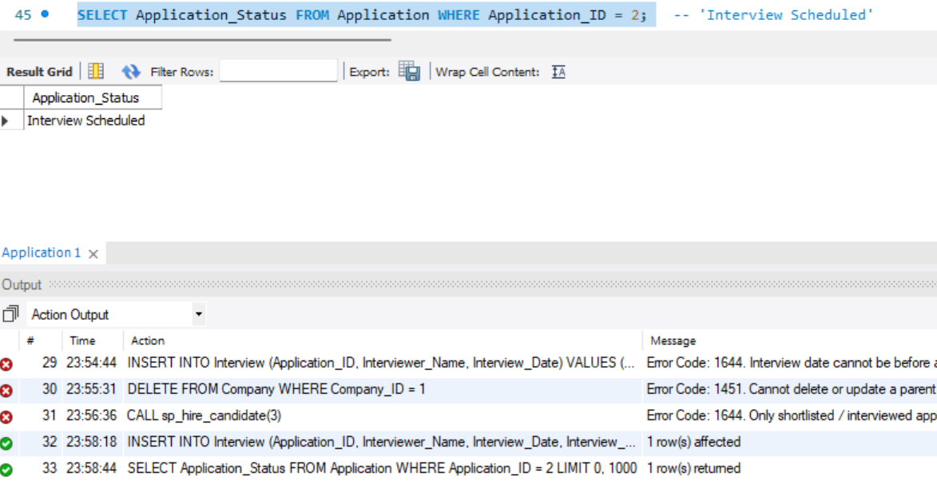
Figure 90: P1: Application 2 is now Interview Scheduled

P2: cascade delete inside a transaction
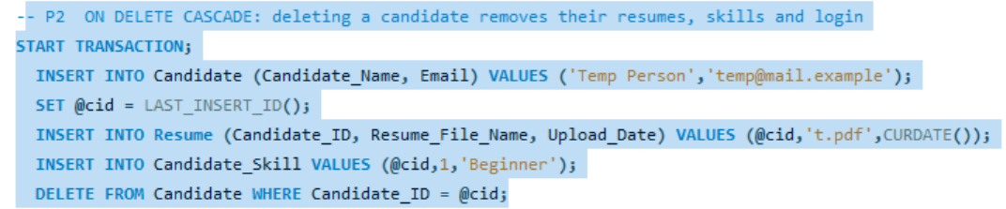
Figure 91: P2: transaction statements
Figure 92: P2: output
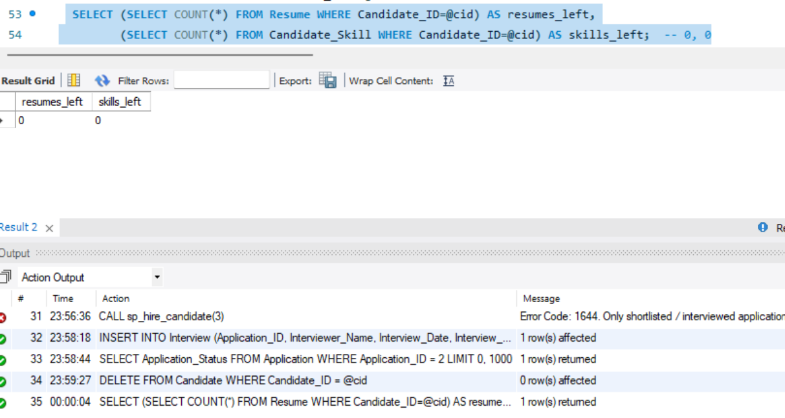
Figure 93: P2: result
Re-run P2 as one block (select all statements, then Execute) so that @cid is set and the DELETE affects one row; replace these screenshots with the new output.

P3: audit log after hiring
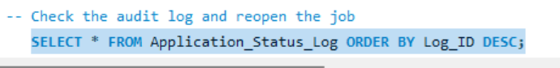
Figure 94: Audit log query
Figure 95: Audit log: output
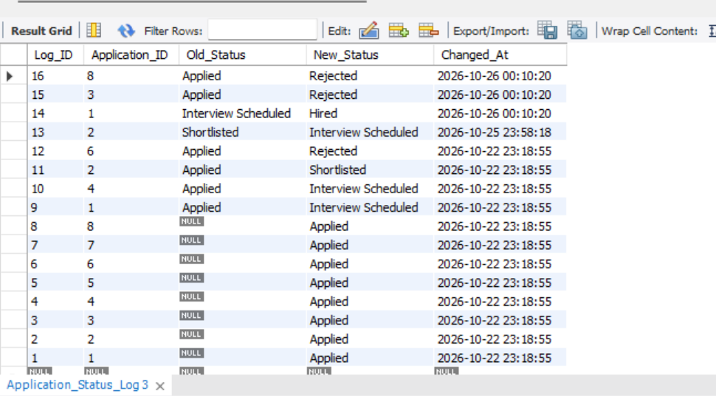
Figure 96: Audit log: the hire, the two automatic rejections and earlier changes
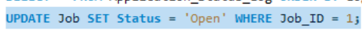
Figure 97: Job 1 reopened for the application demo
Figure 98: Reopen: output

10. Conclusion
The project delivers a recruitment platform that goes beyond CRUD. Relational data lives in MySQL, where constraints, triggers and transactions guarantee consistency regardless of the client, and unstructured resume and job text lives in a vector database, where semantic similarity adds value that keyword search cannot. The Next.js layer adds authentication, role-based access and a usable interface over the database features.

10.1 What was achieved
- A normalised 12-table schema with keys, CHECK/UNIQUE constraints and referential actions chosen per relationship.
- Six advanced SQL features: transactions, views, function and procedures, triggers, indexing and full-text search, plus vector similarity search.
- A hybrid search design in which Qdrant finds nearest neighbours and MySQL filters and enriches the results.
- Security by design: hashed passwords, JWT in HttpOnly cookies, role checks on every API, parameterised queries and secrets in environment variables.
- Systematic tests showing that invalid data is rejected by the database itself.

10.2 Limitations and future work
- Resumes are entered as text; PDF and DOCX parsing would remove manual copy-paste.
- Ranking could combine cosine similarity with the skill-match percentage into one score.
- Email notifications for status changes and interview invitations.
- Pagination and caching for large datasets; automated end-to-end tests.

10.3 Team contributions and repository
Member | Contribution
PES2UG24CS535 | Schema extensions, views, functions, procedures and triggers, important queries, data dictionary; authentication, jobs, applications and interviews APIs and pages
PES2UG24CS527 | Seed data and test cases; Qdrant design, embedding pipeline and semantic search; dashboard, candidates, profile and match pages; documentation

Source code, SQL scripts and setup instructions are maintained in a Git/GitHub repository, with individual contributions visible in the commit history. Repository link: https://github.com/<username>/recruitment-app (replace with the final URL).

